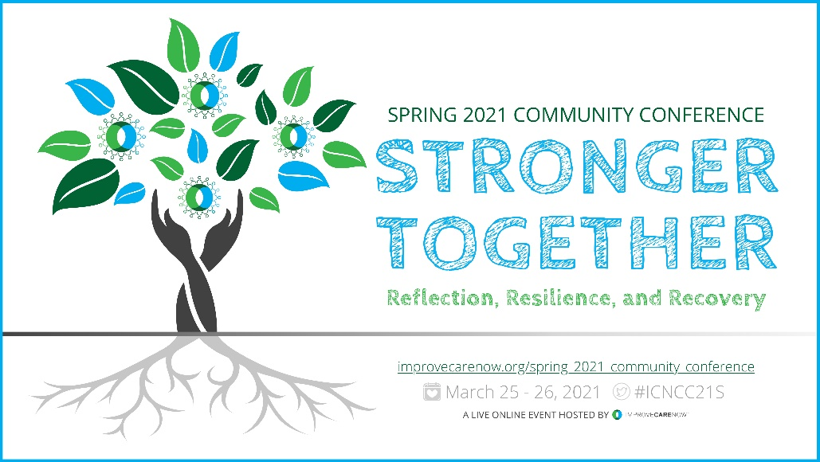

[___] has been invited to attend the pediatric IBD focused ImproveCareNow Spring Live Online Community Conference. The conference will be held March 25-26.
The learning event fosters an environment enhancing professional and personal growth while providing a forum to share updates in research related to improving outcomes in the pediatric inflammatory bowel disease field.
During this conference, [__] will:
- Integrate best practices at your care center focused on equity, outcomes, engagement and using technology to change outcomes.
- Acquire new ideas on how to partner with patients and parents in meaningful ways to grow your local improvement community.
- Plan a test of change at your care center in alignment with Pathway to Mastery Outcomes and Objectives.
- Demonstrate ImproveCareNow quality improvement, research, and community engagement skills.
- Develop connections and relationships with clinicians, patients, parents, and trusted partners to work together in new ways to benefit the IBD community.

The variety of educational topics would allow him/her to attend several sessions directly applicable to [__] work at [___]. The sessions are led by respected leaders in pediatric gastroenterology and will enhance his/her knowledge of research, evidence-based practice, and hot topics in pediatric inflammatory bowel disease. Furthermore, the sessions will enable [__] to see evidence-based initiatives at other hospitals and to speak directly with physicians, nurses and other health care providers involved in their implementation.
Sincerely,
The ImproveCareNow Conference Planning Team

