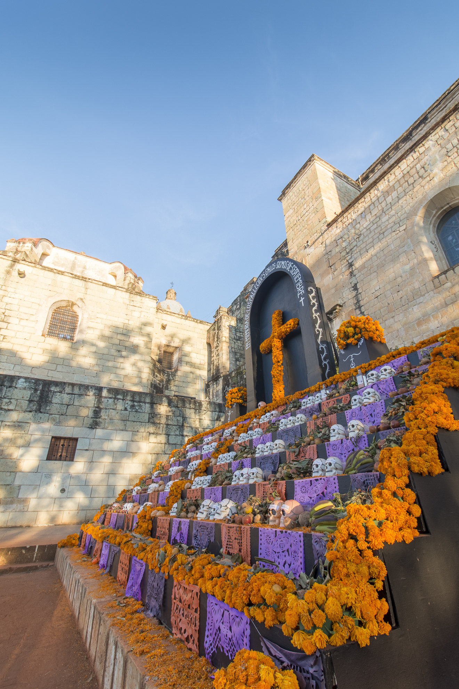

SAMPLE ITINERARY
DAY OF THE DEAD IN
OAXACA 2020
DAY OF THE DEAD IN OAXACA 2020
- Custom Itinerary -

Make 2020 the year you experience the incredible Day of the Dead celebrations in Oaxaca. This one-of-a-kind festival – which celebrates life, death, and everything in between – is a vibrant fiesta of elaborate costumes, grand feasts, and vivid colors. But it’s also a time for quiet reflection and poignant moments to remember lost loved-ones.

Travel with Journey Mexico and we’ll craft a fully personalized itinerary to let you experience Day of the Dead on your owns terms without the hassle of traveling with a group. Take a read through the suggested itinerary below – remember, everything can be altered to your preferences – to get a feel of what your Day of the Dead in Oaxaca could be.

Suggested Day of Dead in Oaxaca Vacation
Experience a Day of the Dead celebration like no other, traveling to Oaxaca for a fully immersive dive into the world’s most intriguing festival of life and death! Starting on October 28, enjoy seven days on a private tour, experiencing the full spectrum of the Dia de Muertos festivities.

From vibrant and colorful street parades to poignant and intimate displays in the family home, this unforgettable vacation – which is fully customizable to your preferences – is the ultimate way to experience everything Day of the Dead has to offer.

DAY-BY-DAY ITINERARY

DAY 1: ARRIVAL IN OAXACA – OCT 28
Arrive in Oaxaca and enjoy luxury from the off with a private transfer to your hotel. Spend the rest of the day at leisure, relaxing at your accommodation or strolling the streets of Oaxaca.

For dinner, take the opportunity to explore Oaxaca’s world-famous culinary scene by taking an expertly guided food tour or heading to one of the city’s many fine gourmet restaurants.

Accommodation: Hotel Quinta Real Oaxaca

DAY 2-3: EXPLORE OAXACA – OCT 29-30
Spend two days getting to know the true Oaxaca, a city of infinite beauty, before the Day of the Dead celebrations get into full swing. With an expert guide taking the lead, visit the city’s highlights such as its plazas and architectural gems.

A further exploration of the food is a must. Sample local delicacies including Oaxacan cheese and grasshoppers and, perhaps, head to the traditional chocolate mills to see how they work and taste Oaxaca’s specialty chocolate.

You may also opt to explore Mexico’s much-loved spirit, mezcal, explore the archeological site of Mitla, or get creative with a private cooking class in Mexico’s culinary capital.

DAY 4: DAY OF THE DEAD MARKETS WITH LOCAL HOME VISIT – OCT 31
Begin your Day of the Dead experience in Oaxaca’s sprawling markets, watching the locals prepare for the festivities by purchasing fresh bread, candles, incense, sugar skulls, and more. This is a great chance to pick up a gift or two for your loved-ones back home.

You may also want to see how traditional Day of the Dead altars are created, while learning all about their significance and the role they play in the holiday.

A humbling experience comes when you’re invited, as a special guest, to the homes of local Oaxacans to see the alters they have created for their dead relatives. After, try traditional pan de muerto bread and the hot chocolate that goes with it.

Finally, when the night draws in, head to a cemetery for a twilight vigil and to see how the locals adorn graves with flowers and candles.

DAY 5-6: DAY OF THE DEAD PARADE AND CULTURAL ACTIVITIES – NOV 1-2
As the Day of the Dead celebrations reach their peak, witness the famous Dia de Muertos parades in Oaxaca’s north valley, in which locals dress up in a variety of colorful skeleton-themed costumes and march through the streets.
You may also want to take the chance to visit Monte Alban archaeological site, one of the oldest cities in Mesoamerica, or venture to one of the nearby villages to discover Oaxaca’s rich traditions for producing artisanal, home-made products.

DAY 7: DEPARTURE DAY – NOV 3
On your departure day, enjoy a private transfer from the hotel to the airport for your onward flight home.

