Join us for Catholic Charities Ministries of Mercy 75th Anniversary Celebration
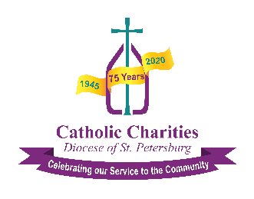

Option #2 (Preferred)
What: Catholic Charities will gather to celebrate its 75th Anniversary
- Hosted by Bobby Lewis, CBS channel 10 feature reporter
- Interviews with donors, staff and board members
- Musical entertainment (live and pre-recorded)
- Informative videos on several ministry programs
- Donate and Enter: text mercy to 91999 (https://igfn.us/f/1d5p/n) or email catholiccharitiesdosp@gmail.com
  - Buy a $75 ‘Watch Party’ Party Pack (Catholic Charities-branded items)
  - Donate to spend a night in a Hope Cottage™

Why: Due to the COVID-19 virus we canceled our annual fundraiser. This event replaces it.
Where: Facebook Live (www.facebook.com/CCharitiesDOSP)
- https://fb.me/e/5GVHTMm4b) (to watch without a Facebook account) or
- www.ccdosp.org/fblive
- https://vimeo.com/475201685 (Emcee, Bobby Lewis – Promotional Video)
When: Friday November 20, 2020 at 6:00 pm

