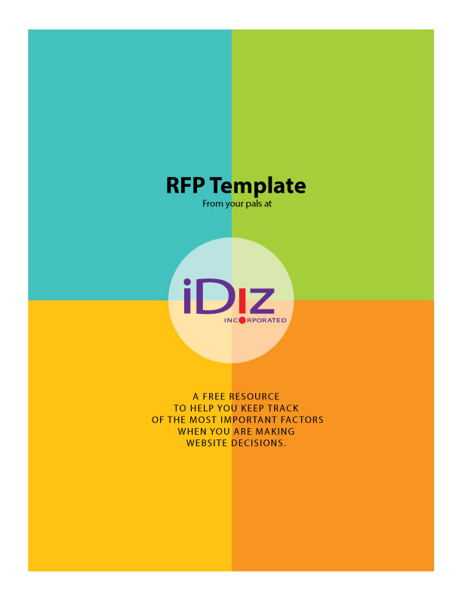

Credit Union Website RFP
Please answer the following questions when you create your proposal.

1. Describe your approach to Design/Creative/UX:

2. Describe the capabilities of your CMS:

3. How do you handle integration with all third-party services? What’s the process for possible future changes that affect the website, such as a new online banking or core provider, a brand or logo update, adding third-party features such as live chat or marketing automation, etc.?

4.Describe your hosting, including where the data center is located, backups and security measures:

5. How does training and tech support work? How are you able to help when we need an extra hand?

6. What SEO & Optimization services do you provide?

7. Are you able to incorporate our existing CRM or marketing automation? Or do you have one that you recommend?

8. What additional capabilities and recommendations do you have?

9. Have you designed websites for other financial institutions? Have you worked with credit unions? If so, please describe and list referrals.

10. Our website is the cornerstone of our marketing and branding. How can you help us leverage and coordinate our website, brand, and marketing investments?

11. We’ll be spending a lot of time together, so it’s important for our teams to have compatible cultures and a high level of mutual trust. How would you describe your team?

12. What other areas of expertise do you have to offer?

Downloaded from https://www.cuidiz.com/website-starter-kit/ and provided by your friends at iDiz.
If you have questions call us at 317.257.0000 or email contact@idizinc.com

