Genetic targets may be a promising future for osteoporosis

supplements
1.Statistical applications LRP5G171R genotypes , femur BMD

Related-Samples McNemar Change Test was used to exams the variant significant under 95% confidence level (α ≤ .050) and studying a null hypothesis interested in LRP5G171Rgenotypes variant of distribution across femur T-score values taking into consideration all genotypes of LRP5G171R
automated cross-tab was used to identify the odd risk for femur T- score observing when LRP5G171Rgenotypes excess comparing with the possibility to observe femur T- score when LRP5G171Rgenotypes absence taking into consideration all genotypes
Chi-Square Tests was used to estimate the correlation between LRP5G171Rgenotypes and each of femur T- score under 95% confidence (α ≤ .050)

  - Related-Samples McNemar Change Test
1.1.1.GG genotype results

Hypothesis Test Summary
 | Null Hypothesis | Test | Sig. | Decision
 | The distributions of different values across GG genotype and normal femur T-score are equally likely. | Related-Samples McNemar Change Test | .025 | Reject the null hypothesis.
 | The distributions of different values across GG genotype and osteopenia femur T-score are equally likely. | Related-Samples McNemar Change Test | .000 | Reject the null hypothesis.
 | The distributions of different values across GG genotype and osteoporosis femur T-score are equally likely. | Related-Samples McNemar Change Test | .000 | Reject the null hypothesis.
Asymptotic significances are displayed. The significance level is .050.

Table.1: Observation hypothesis Test Summary for GG genotype, femur T-score values

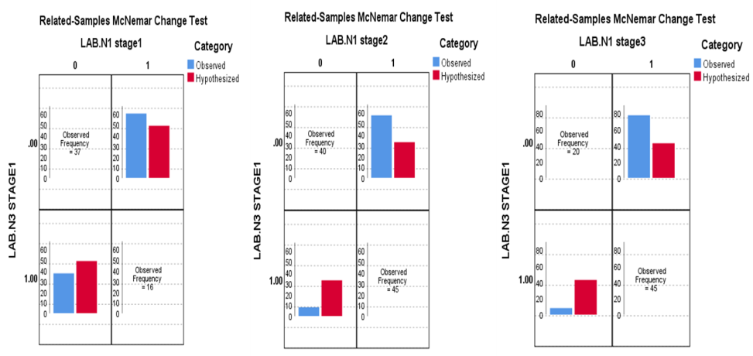Figure.1: Related-Samples McNemar Change Test between GG genotype and normal femur T-score(LAB.N1 stage1), osteopenia femur T-score(LAB.N1 stage2), osteoporosis femur T-score(LAB.N1 stage3).
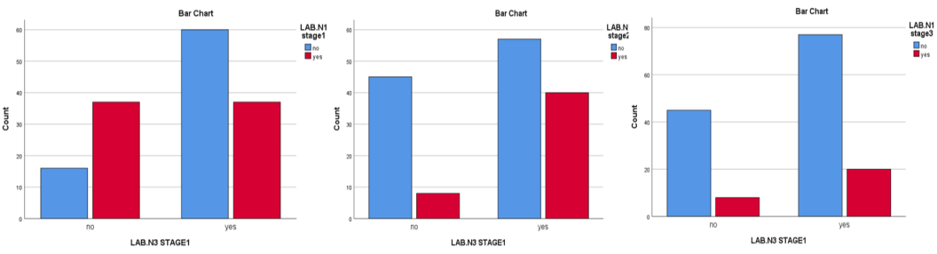Figure .2: Bar chart to the frequency between normal femur T-score(LAB.N1 stage1) osteopenia femur T-score(LAB.N1 stage2), osteoporosis femur T-score(LAB.N1 stage3) and GGgenotype.

Crosstab(GG genotype and normal femur T-score)
Count
 |  | normal femur T-score |  |  |  |  |  |  |  |  |  | Total
 |  | No |  |  |  | Yes
GG genotype | No | 16 |  |  |  | 37 |  |  |  |  |  | 53
 | yes | 60 |  |  |  | 37 |  |  |  |  |  | 97
Total |  | 76 |  |  |  | 74 |  |  |  |  |  | 150
Risk Estimate(GG genotype and normal femur T-score)
 |  |  |  |  | Value |  |  |  |  |  | 95% Confidence Interval
 |  |  |  |  |  |  |  |  |  |  | Lower |  |  |  | Upper
Odds Ratio for GG genotype (no / yes) |  |  |  |  | .267 |  |  |  |  |  | .130 |  |  |  | .545
For cohort normal femur T-score = no |  |  |  |  | .488 |  |  |  |  |  | .315 |  |  |  | .756
For cohort normal femur T-score = yes |  |  |  |  | 1.830 |  |  |  |  |  | 1.344 |  |  |  | 2.493
N of Valid Cases |  |  |  |  | 150
Crosstab(GG genotype and osteopenia femur T-score)
Count
 |  |  | osteopenia femur T-score |  |  |  |  |  |  |  |  |  | Total
 |  |  | No |  |  | Yes
GG genotype | No |  | 45 |  |  | 8 |  |  |  |  |  |  | 53
 | Yes |  | 57 |  |  | 40 |  |  |  |  |  |  | 97
Total |  |  | 102 |  |  | 48 |  |  |  |  |  |  | 150
Risk Estimate(GG genotype and osteopenia femur T-score)
 |  |  |  | Value |  |  |  | 95% Confidence Interval
 |  |  |  |  |  |  |  | Lower |  |  |  |  | Upper
Odds Ratio for GG genotype (no / yes) |  |  |  | 3.947 |  |  |  | 1.681 |  |  |  |  | 9.271
For cohort osteopenia femur T-score = no |  |  |  | 1.445 |  |  |  | 1.181 |  |  |  |  | 1.768
For cohort osteopenia femur T-score = yes |  |  |  | .366 |  |  |  | .185 |  |  |  |  | .723
N of Valid Cases |  |  |  | 150
Crosstab(GG genotype and osteoporosis femur T-score)
Count
 |  | osteoporosis femur T-score |  |  |  |  |  |  | Total
 |  | No |  |  |  | Yes
GG genotype | No | 45 |  |  |  | 8 |  |  | 53
 | yes | 77 |  |  |  | 20 |  |  | 97
Total |  | 122 |  |  |  | 28 |  |  | 150
Risk Estimate(GG genotype and osteoporosis femur T-score)
 |  |  |  |  |  |  | Value |  |  | 95% Confidence Interval
 |  |  |  |  |  |  |  |  |  | Lower |  |  |  | Upper
Odds Ratio for GG genotype (no / yes) |  |  |  |  |  |  | 1.461 |  |  | .595 |  |  |  | 3.589
For cohort osteoporosis femur T-score= no |  |  |  |  |  |  | 1.070 |  |  | .919 |  |  |  | 1.245
For cohort osteoporosis femur T-score= yes |  |  |  |  |  |  | .732 |  |  | .346 |  |  |  | 1.547
N of Valid Cases |  |  |  |  |  |  | 150
Table.2: Results of cross-tab and risk estimate tests were used to identify the odd risk for femur T-score values when GG genotype is absence or existed.

Chi-Square Tests (GG genotype and normal femur T-score)
 | Value | Df | Asymptotic Significance (2-sided) | Exact Sig. (2-sided) | Exact Sig. (1-sided)
Pearson Chi-Square | 13.750ª | 1 | .000
a. 0 cells (0.0%) have expected count less than 5. The minimum expected count is 26.15.
b. Computed only for a 2x2 table
Chi-Square Tests( GG genotype and osteopenia femur T-score)
 | Value | Df | Asymptotic Significance (2-sided) | Exact Sig. (2-sided) | Exact Sig. (1-sided)
Pearson Chi-Square | 10.765ª | 1 | .001
a. 0 cells (0.0%) have expected count less than 5. The minimum expected count is 16.96.
b. Computed only for a 2x2 table
Chi-Square Tests (GG genotype and osteoporosis femur T-score)
 | Value | df | Asymptotic Significance (2-sided) | Exact Sig. (2-sided) | Exact Sig. (1-sided)
Pearson Chi-Square | .689ª | 1 | .407
a. 0 cells (0.0%) have expected count less than 5. The minimum expected count is 9.89.
b. Computed only for a 2x2 table
Table.3: Results of Chi-Square Tests for GG genotype and femur T-score values

1.1.2. CC genotype results

Hypothesis Test Summary
 | Null Hypothesis | Test | Sig. | Decision
 | The distributions of different values across CC genotype and normal femur T-score are equally likely. | Related-Samples McNemar Change Test | .000 | Reject the null hypothesis.
 | The distributions of different values across CC genotype and osteopenia femur T-score are equally likely. | Related-Samples McNemar Change Test | .001 | Reject the null hypothesis.

 | The distributions of different values across CC genotype and osteoporosis femur T-score are equally likely. | Related-Samples McNemar Change Test | .280 | Retain the null hypothesis.
Asymptotic significances are displayed. The significance level is .050.

Table.4: Observation hypothesis Test Summary for CC genotype, femur T-score values

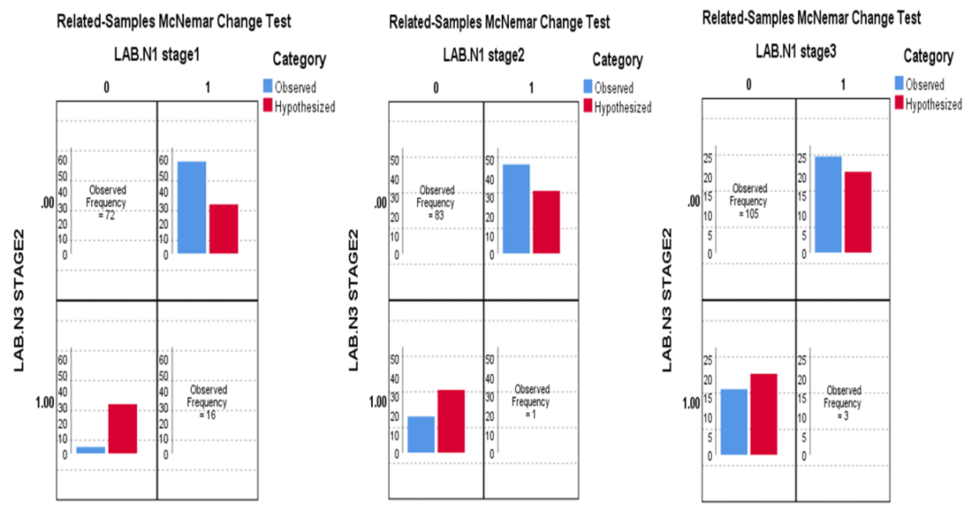Figure.3: Related-Samples McNemar Change Test between CC genotype and normal femur T-score(LAB.N1 stage1), osteopenia femur T-score(LAB.N1 stage2), osteoporosis femur T-score(LAB.N1 stage3).

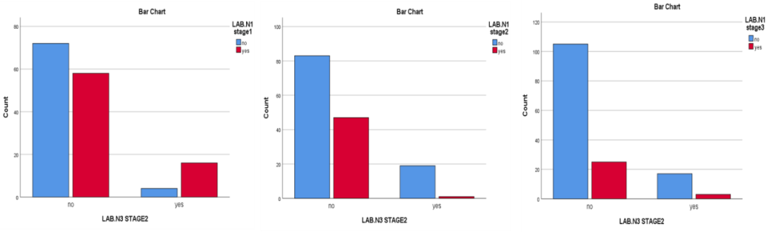
Figure.4: Bar chart to the frequency between normal femur T-score(LAB.N1 stage1), osteopenia femur T-score(LAB.N1 stage2), osteoporosis femur T-score(LAB.N1 stage3) and CC genotype.
Crosstab (CC genotype and normal femur T-score)
Count
 |  | normal femur T-score |  | Total
 |  | No | yes
CC genotype | no | 72 | 58 | 130
 | yes | 4 | 16 | 20
Total |  | 76 | 74 | 150
Risk Estimate(CC genotype and normal femur T-score)
 |  |  |  |  | Value | 95% Confidence Interval
 |  |  |  |  |  | Lower | Upper
Odds Ratio for CC genotype (no / yes) |  |  |  |  | 4.966 | 1.574 | 15.665
For cohort normal femur T-score = no |  |  |  |  | 2.769 | 1.137 | 6.743
For cohort normal femur T-score = yes |  |  |  |  | .558 | .417 | .746
N of Valid Cases |  |  |  |  | 150
Crosstab(CC genotype and osteopenia femur T-score)
Count
 |  | osteopenia femur T-score |  | Total
 |  | No | yes
CC genotype | no | 83 | 47 | 130
 | yes | 19 | 1 | 20
Total |  | 102 | 48 | 150

Crosstab(CC genotype, osteoporosis femur T-score)
Count
 |  | osteoporosis femur T-score |  | Total
 |  | No | yes
CC genotype | No | 105 | 25 | 130
 | yes | 17 | 3 | 20
Total |  | 122 | 28 | 150
Risk Estimate(CC genotype and osteopenia femur T-score)
 | Value | 95% Confidence Interval
 |  | Lower | Upper
Odds Ratio for CC genotype (no / yes) | .093 | .012 | .717
For cohort osteopenia femur T-score = no | .672 | .571 | .792
For cohort osteopenia femur T-score = yes | 7.231 | 1.056 | 49.516
N of Valid Cases | 150

Risk Estimate(CC genotype and osteoporosis femur T-score)
 | Value | 95% Confidence Interval
 |  | Lower | Upper
Odds Ratio for CC genotype (no / yes) | .741 | .201 | 2.727
For cohort osteoporosis femur T-score = no | .950 | .776 | 1.163
For cohort osteoporosis femur T-score = yes | 1.282 | .426 | 3.856
N of Valid Cases | 150
Table.5: Results of cross-tab and risk estimate tests were used to identify the odd risk for femur T-score values when CC genotype is absence or existed.
Chi-Square Tests(CC genotype, normal femur T-score)
 | Value |  |  | df |  |  | Asymptotic Significance (2-sided) |  | Exact Sig. (2-sided) |  | Exact Sig. (1-sided)
Pearson Chi-Square | 8.683ª |  |  | 1 |  |  | .003
a. 0 cells (0.0%) have expected count less than 5. The minimum expected count is 9.87.
b. Computed only for a 2x2 table
Chi-Square Tests(CC genotype, osteopenia femur T-score)
 |  |  | Value |  |  | Df |  | Asymptotic Significance (2-sided) |  | Exact Sig. (2-sided) |  | Exact Sig. (1-sided)
Pearson Chi-Square |  |  | 7.731ª |  |  | 1 |  | .005
a. 0 cells (0.0%) have expected count less than 5. The minimum expected count is 6.40.
b. Computed only for a 2x2 table
Chi-Square Tests(CC genotype, osteoporosis femur T-score)
 |  | Value |  |  | df |  | Asymptotic Significance (2-sided) |  |  | Exact Sig. (2-sided) |  | Exact Sig. (1-sided)
Pearson Chi-Square |  | .204ª |  |  | 1 |  | .651
a. 1 cells (25.0%) have expected count less than 5. The minimum expected count is 3.73.
b. Computed only for a 2x2 table
Table.6: Results of Chi-Square Tests for CC genotype and femur T-score values

1.1.3.GC genotype results:

Hypothesis Test Summary
 | Null Hypothesis | Test | Sig. | Decision
 | The distributions of different values across LAB.N3 STAGE3 and LAB.N1 stage1 are equally likely. | Related-Samples McNemar Change Test | .000 | Reject the null hypothesis.
 | The distributions of different values across GC genotype and osteopenia femur T-score are equally likely. | Related-Samples McNemar Change Test | .087 | Retain the null hypothesis.
 | The distributions of different values across GC genotype and osteoporosis femur T-score are equally likely. | Related-Samples McNemar Change Test | .575 | Retain the null hypothesis.
Asymptotic significances are displayed. The significance level is .050.
Table. 7: Observation hypothesis Test Summary for GC genotype, femur T-score values

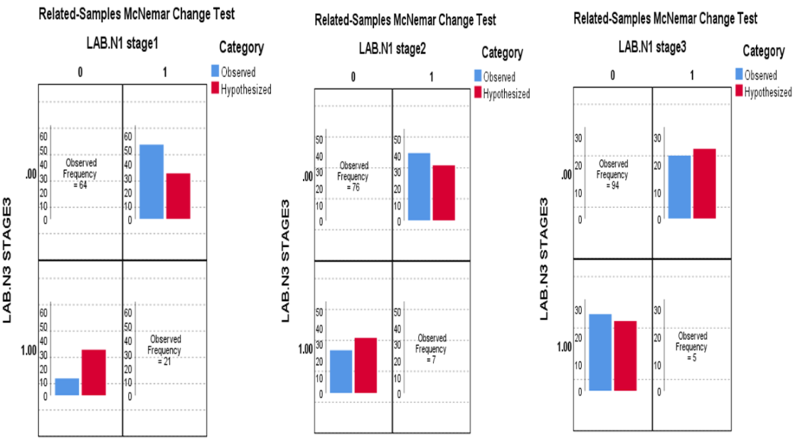Figure.5: Related-Samples McNemar Change Test between GC genotype and normal femur T-score(LAB.N1 stage1), osteopenia femur T-score(LAB.N1 stage2), osteoporosis femur T-score(LAB.N1 stage3).

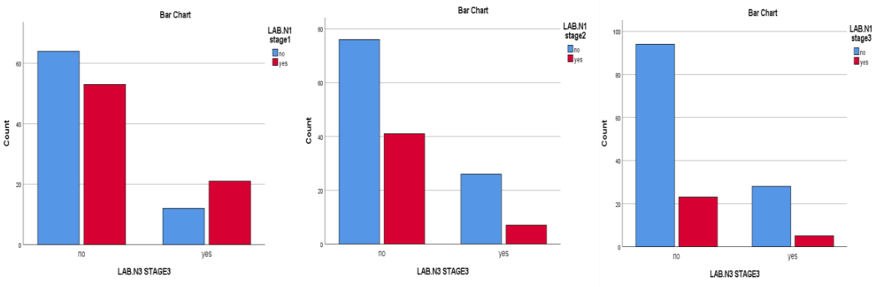Figure.6: Bar chart to the frequency between normal femur T-score(LAB.N1 stage1) osteopenia femur T-score(LAB.N1 stage2), osteoporosis femur T-score(LAB.N1 stage3) and GC genotype

Crosstab(GC genotype, normal femur T-score)
Count
 |  | normal femur T-score |  | Total
 |  | No | yes
GC genotype | no | 64 | 53 | 117
 | yes | 12 | 21 | 33
Total |  | 76 | 74 | 150

Risk Estimate(GC genotype, normal femur T-score)
 |  |  |  | Value |  |  |  | 95% Confidence Interval
 |  |  |  |  |  |  |  | Lower |  |  | Upper
Odds Ratio for GC genotype (no / yes) |  |  |  | 2.113 |  |  |  | .952 |  |  | 4.690
For cohort normal femur T-score = no |  |  |  | 1.504 |  |  |  | .930 |  |  | 2.432
For cohort normal femur T-score = yes |  |  |  | .712 |  |  |  | .514 |  |  | .986
N of Valid Cases |  |  |  | 150
Crosstab(GC genotype, osteopenia femur T-score)
Count
 |  | osteopenia femur T-score |  |  |  |  | Total
 |  | No | yes
GC genotype | no | 76 | 41 |  |  |  | 117
 | yes | 26 | 7 |  |  |  | 33
Total |  | 102 | 48 |  |  |  | 150
Risk Estimate(GC genotype, osteopenia femur T-score)
 |  |  |  |  |  | Value |  |  | 95% Confidence Interval
 |  |  |  |  |  |  |  |  | Lower |  |  | Upper
Odds Ratio for GC genotype (no / yes) |  |  |  |  |  | .499 |  |  | .199 |  |  | 1.248
For cohort osteopenia femur T-score = no |  |  |  |  |  | .824 |  |  | .661 |  |  | 1.029
For cohort osteopenia femur T-score = yes |  |  |  |  |  | 1.652 |  |  | .818 |  |  | 3.334
N of Valid Cases |  |  |  |  |  | 150
Crosstab(GC genotype, osteoporosis femur T-score)
Count
 |  | osteoporosis femur T-score |  |  |  |  |  |  |  | Total
 |  | No | Yes
GC genotype | no | 94 | 23 |  |  |  |  |  |  | 117
 | yes | 28 | 5 |  |  |  |  |  |  | 33
Total |  | 122 | 28 |  |  |  |  |  |  | 150
Risk Estimate(GC genotype, osteoporosis femur T-score)
 |  |  |  |  | Value |  |  |  |  | 95% Confidence Interval
 |  |  |  |  |  |  |  |  |  | Lower |  | Upper
Odds Ratio for GC genotype (no / yes) |  |  |  |  | .730 |  |  |  |  | .254 |  | 2.096
For cohort osteoporosis femur T-score = no |  |  |  |  | .947 |  |  |  |  | .799 |  | 1.122
For cohort osteoporosis femur T-score = yes |  |  |  |  | 1.297 |  |  |  |  | .535 |  | 3.149
N of Valid Cases |  |  |  |  | 150
Table.8: Results of cross-tab and risk estimate tests were used to identify the odd risk for femur T-score values when LRP5G171R genotype is absence or existed.

Chi-Square Tests(GC genotype, normal femur T-score)
 |  | Value | Df |  | Asymptotic Significance (2-sided) | Exact Sig. (2-sided) | Exact Sig. (1-sided)
Pearson Chi-Square |  | 3.463ª | 1 |  | .063
a. 0 cells (0.0%) have expected count less than 5. The minimum expected count is 16.28.
b. Computed only for a 2x2 table
Chi-Square Tests(GC genotype, osteopenia femur T-score)
 |  | Value | Df |  | Asymptotic Significance (2-sided) | Exact Sig. (2-sided) |  | Exact Sig. (1-sided)
Pearson Chi-Square |  | 2.263ª | 1 |  | .133
a. 0 cells (0.0%) have expected count less than 5. The minimum expected count is 10.56.
b. Computed only for a 2x2 table
Chi-Square Tests (GC genotype, osteoporosis femur T-score)
 | Value |  |  | Df | Asymptotic Significance (2-sided) | Exact Sig. (2-sided) |  | Exact Sig. (1-sided)
Pearson Chi-Square | .344ª |  |  | 1 | .557
a. 0 cells (0.0%) have expected count less than 5. The minimum expected count is 6.16.
b. Computed only for a 2x2 table
Table.9: Results of Chi-Square Tests for GC genotype and femur T-score values
2.Statistical applications LRP5G171R genotypes , BMI

Likelihood ratio test was used to determine the predictive power of BMI. Multinomial logistic regression was used to estimate the predictability under 95% confidence level (α ≤ .050) and odds ratios of CC genotype occurrence rather than GG genotype , and GC genotype occurrence rather than GG genotype with respecting the variety of BMI. Chi-Square Tests was used to estimate the correlation between each of the studied variant level with every genotype that happened to be studied under 95% confidence (α ≤ .050) with backing to and aiding by the sign of the multiple regression slope coefficient to recognize the correlation direction
Likelihood Ratio Tests
Effect | Model Fitting Criteria | Likelihood Ratio Tests
 | -2 Log Likelihood of Reduced Model | Chi-Square | df | Sig.
BMI | 149.832 | 15.658 | 8 | .048
The chi-square statistic is the difference in -2 log-likelihoods between the final model and a reduced model. The reduced model is formed by omitting an effect from the final model. The null hypothesis is that all parameters of that effect are 0.
a. This reduced model is equivalent to the final model because omitting the effect does not increase the degrees of freedom.
Table10: Likelihood Ratio Tests which appear the correlation between (BMI) and genotypes of LRP5rs121908669 (ϰ2 = 149.832, p = .048 <.05) .
The predictability under 95% confidence level (α ≤ .050) and odds ratios of genotypes of LRP5G171R with respecting the variety of BMI;
Parameter Estimates
LRP5G171R genotyping |  | B | Std. Error | Wald | df | Sig. | Exp(B) | 95% Confidence Interval for Exp(B)
 |  |  |  |  |  |  |  | Lower Bound | Upper Bound
CC genotyping | Intercept | 3.931 | 2.439 | 2.599 | 1 | .107
 | <18.5 | -8.244 | 5.268 | 2.449 | 1 | .118 | .000 | 8.626E-9 | 8.007
 | [ 18.5- 24.9] | -8.374 | 4.526 | 3.424 | 1 | .064 | .000 | 3.245E-8 | 1.643
 | [ 25- 29.9] | -4.712 | 1.965 | 5.750 | 1 | .016 | .009 | .000 | .423
 | [30- 34.9] | -3.280 | 1.887 | 3.024 | 1 | .082 | .038 | .001 | 1.518
 | ≥35 | 0^{b} | . | . | 0 | . | . | . | .
GC genotype | Intercept | 2.851 | 1.871 | 2.322 | 1 | .128
 | <18.5 | -2.271 | 3.037 | .559 | 1 | .455 | .103 | .000 | 39.708
 | [ 18.5- 24.9] | -2.802 | 2.702 | 1.075 | 1 | .300 | .061 | .000 | 12.120
 | [ 25- 29.9] | -1.288 | 1.599 | .649 | 1 | .421 | .276 | .012 | 6.333
 | [30- 34.9] | .650 | 1.538 | .179 | 1 | .673 | 1.915 | .094 | 38.982
 | ≥35 | 0^{b} | . | . | 0 | . | . | . | .
a. The reference category is: GG genotype.
b. This parameter is set to zero because it is redundant.
Table11: Multinomial logistic regression which was used to estimate the predictability under 95% confidence level (α ≤ .050) and odds ratios of genotypes of LRP5G171R with respecting the variety of BMI
Crosstab(GG genotype * BMI<18.5)

Count
 |  | BMI<18.5 |  | Total
 |  | no | yes
GG genotype | No | 51 | 2 | 53
 | yes | 93 | 4 | 97
Total |  | 144 | 6 | 150
Crosstab(GG genotype * BMI[18.5-24.9])
Count
 |  | BMI[18.5-24.9] |  | Total
 |  | no | yes
GG genotype | no | 49 | 4 | 53
 | yes | 56 | 41 | 97
Total |  | 105 | 45 | 150
Crosstab GG genotype * BMI[25-29.9]
Count
 |  | BMI[25-29.9] |  | Total
 |  | no | yes
GG genotype | no | 36 | 17 | 53
 | yes | 53 | 44 | 97
Total |  | 89 | 61 | 150
Crosstab(GG genotype * BMI[30-34.9])
Count
 |  | BMI[30-34.9] |  | Total
 |  | no | yes
GG genotype | no | 32 | 21 | 53
 | yes | 90 | 7 | 97
Total |  | 122 | 28 | 150
Crosstab GG genotype * BMI≥35
Count
 |  | BMI≥35 |  | Total
 |  | no | yes
GG genotype | no | 44 | 9 | 53
 | yes | 96 | 1 | 97
Total |  | 140 | 10 | 150
Crosstab (CC genotype * BMI<18.5)
Count
 |  | BMI<18.5 |  | Total
 |  | no | Yes
CC genotype | no | 125 | 5 | 130
 | yes | 19 | 1 | 20
Total |  | 144 | 6 | 150
Crosstab(CC genotype * BMI[18.5-24.9])
Count
 |  | BMI[18.5-24.9] |  | Total
 |  | no | yes
CCgenotype | no | 86 | 44 | 130
 | yes | 19 | 1 | 20
Total |  | 105 | 45 | 150
Crosstab(CC genotype * BMI[25-29.9])
Count
 |  | BMI[25-29.9] |  | Total
 |  | no | yes
CC genotype | no | 76 | 54 | 130
 | yes | 13 | 7 | 20
Total |  | 89 | 61 | 150
Crosstab(CC genotype * BMI[30-34.9])
Count
 |  | BMI[30-34.9] |  | Total
 |  | no | yes
CC genotype | no | 108 | 22 | 130
 | yes | 14 | 6 | 20
Total |  | 122 | 28 | 150
Crosstab(CC genotype * BMI≥35)
Count
 |  | BMI≥35 |  | Total
 |  | no | Yes
CC genotype | no | 125 | 5 | 130
 | yes | 15 | 5 | 20
Total |  | 140 | 10 | 150
Crosstab(GC genotype * BMI<18.5)
Count
 |  | BMI<18.5 |  | Total
 |  | no | Yes
GC genotype | no | 112 | 5 | 117
 | yes | 32 | 1 | 33
Total |  | 144 | 6 | 150
Crosstab(GCgenotype * BMI[18.5-24.9])
Count
 |  | BMI[18.5-24.9] |  | Total
 |  | no | yes
GC genotype | no | 75 | 42 | 117
 | yes | 30 | 3 | 33
Total |  | 105 | 45 | 150
Crosstab(GC genotype * BMI[25-29.9])
Count
 |  | BMI[25-29.9] |  | Total
 |  | no | yes
GC genotype | no | 66 | 51 | 117
 | yes | 23 | 10 | 33
Total |  | 89 | 61 | 150
Crosstab(GC genotype * BMI[30-34.9])
Count
 |  | BMI[30-34.9] |  | Total
 |  | No | yes
GC genotype | no | 104 | 13 | 117
 | yes | 18 | 15 | 33
Total |  | 122 | 28 | 150
Crosstab(GC genotype * BMI≥35)
Count
 |  | BMI≥35 |  | Total
 |  | no | Yes
GC genotype | no | 111 | 6 | 117
 | yes | 29 | 4 | 33
Total |  | 140 | 10 | 150
Chi-Square Tests(GG genotype * BMI<18.5)
 | Value | df | Asymptotic Significance (2-sided) | Exact Sig. (2-sided) | Exact Sig. (1-sided)
Pearson Chi-Square | .011ª | 1 | .917
a. 2 cells (50.0%) have expected count less than 5. The minimum expected count is 2.12.
b. Computed only for a 2x2 table
Chi-Square Tests(GG genotype * BMI[18.5-24.9])
 | Value | df | Asymptotic Significance (2-sided) | Exact Sig. (2-sided) | Exact Sig. (1-sided)
Pearson Chi-Square | 19.675ª | 1 | .000
a. 0 cells (0.0%) have expected count less than 5. The minimum expected count is 15.90.
b. Computed only for a 2x2 table
Chi-Square Tests GG genotype * BMI[25-29.9]
 | Value | df | Asymptotic Significance (2-sided) | Exact Sig. (2-sided) | Exact Sig. (1-sided)
Pearson Chi-Square | 2.507ª | 1 | .113
a. 0 cells (0.0%) have expected count less than 5. The minimum expected count is 21.55.
b. Computed only for a 2x2 table
Chi-Square Tests(GG genotype * BMI[30-34.9])
 | Value | df | Asymptotic Significance (2-sided) | Exact Sig. (2-sided) | Exact Sig. (1-sided)
Pearson Chi-Square | 23.707ª | 1 | .000
a. 0 cells (0.0%) have expected count less than 5. The minimum expected count is 9.89.
b. Computed only for a 2x2 table
Chi-Square Tests GG genotype * BMI≥35
 | Value | df | Asymptotic Significance (2-sided) | Exact Sig. (2-sided) | Exact Sig. (1-sided)
Pearson Chi-Square | 14.013ª | 1 | .000
a. 1 cells (25.0%) have expected count less than 5. The minimum expected count is 3.53.
b. Computed only for a 2x2 table
Chi-Square Tests (CC genotype * BMI<18.5)
 | Value | df | Asymptotic Significance (2-sided) | Exact Sig. (2-sided) | Exact Sig. (1-sided)
Pearson Chi-Square | .060ª | 1 | .806
a. 1 cells (25.0%) have expected count less than 5. The minimum expected count is .80.
b. Computed only for a 2x2 table
Chi-Square Tests(CC genotype * BMI[18.5-24.9])
 | Value | Df | Asymptotic Significance (2-sided) | Exact Sig. (2-sided) | Exact Sig. (1-sided)
Pearson Chi-Square | 6.868ª | 1 | .009
a. 0 cells (0.0%) have expected count less than 5. The minimum expected count is 6.00.
b. Computed only for a 2x2 table
Chi-Square Tests(CC genotype * BMI[25-29.9])
 | Value | Df | Asymptotic Significance (2-sided) | Exact Sig. (2-sided) | Exact Sig. (1-sided)
Pearson Chi-Square | .307ª | 1 | .579
a. 0 cells (0.0%) have expected count less than 5. The minimum expected count is 8.13.
b. Computed only for a 2x2 table
Chi-Square Tests(CC genotype * BMI[30-34.9])
 | Value | Df | Asymptotic Significance (2-sided) | Exact Sig. (2-sided) | Exact Sig. (1-sided)
Pearson Chi-Square | 1.952ª | 1 | .162
a. 1 cells (25.0%) have expected count less than 5. The minimum expected count is 3.73.
b. Computed only for a 2x2 table
Chi-Square Tests(CC genotype * BMI≥35)
 | Value | Df | Asymptotic Significance (2-sided) | Exact Sig. (2-sided) | Exact Sig. (1-sided)
Pearson Chi-Square | 12.466ª | 1 | .000
a. 1 cells (25.0%) have expected count less than 5. The minimum expected count is 1.33.
b. Computed only for a 2x2 table
Chi-Square Tests(GC genotype * BMI<18.5)
 | Value | Df | Asymptotic Significance (2-sided) | Exact Sig. (2-sided) | Exact Sig. (1-sided)
Pearson Chi-Square | .104ª | 1 | .748
a. 2 cells (50.0%) have expected count less than 5. The minimum expected count is 1.32.
b. Computed only for a 2x2 table
Chi-Square Tests(GCgenotype * BMI[18.5-24.9])
 |  | Value |  | Df |  | Asymptotic Significance (2-sided) | Exact Sig. (2-sided) | Exact Sig. (1-sided)
Pearson Chi-Square |  | 8.808ª |  | 1 |  | .003
a. 0 cells (.0%) have expected count less than 5. The minimum expected count is 9.90.
b. Computed only for a 2x2 table
Chi-Square Tests(GC genotype * BMI[25-29.9])
 | Value |  |  | Df |  | Asymptotic Significance (2-sided) | Exact Sig. (2-sided) | Exact Sig. (1-sided)
Pearson Chi-Square | 1.883ª |  |  | 1 |  | .170
a. 0 cells (.0%) have expected count less than 5. The minimum expected count is 13.42.
b. Computed only for a 2x2 table
Chi-Square Tests(GC genotype * BMI[30-34.9])
 |  |  | Value | Df |  | Asymptotic Significance (2-sided) | Exact Sig. (2-sided) | Exact Sig. (1-sided)
Pearson Chi-Square |  |  | 19.997ª | 1 |  | .000
a. 0 cells (.0%) have expected count less than 5. The minimum expected count is 6.16.
b. Computed only for a 2x2 table
Chi-Square Tests(GC genotype * BMI≥35)
 |  |  | Value |  | Df | Asymptotic Significance (2-sided) | Exact Sig. (2-sided) | Exact Sig. (1-sided)
Pearson Chi-Square |  |  | 2.023ª |  | 1 | .155
a. 1 cells (25.0%) have expected count less than 5. The minimum expected count is 2.20.
b. Com
uted only for a 2x2 table
Table.12: Results of Chi-Square Tests for GG,CC, GC genotype and BMI under 95% confidence (α ≤ .050);
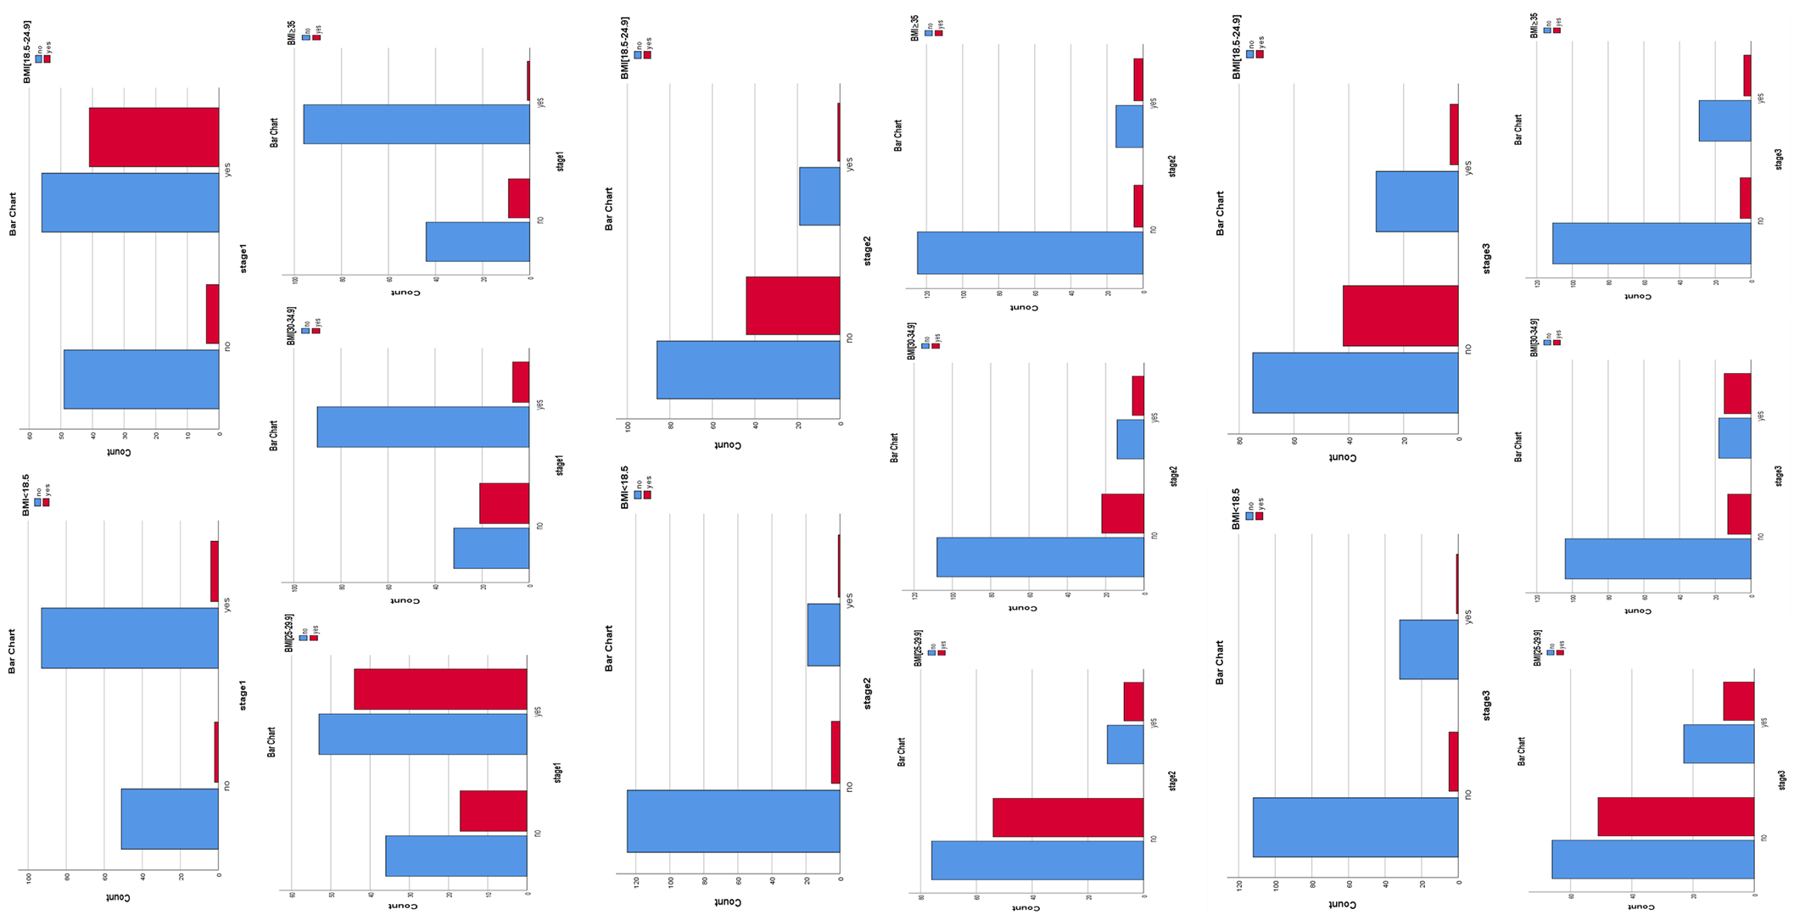
Figure .7: Bar chart to the frequency between BMI groups and GG(stage1)CC(stage2), GC(stage3) genotypes.

3.Statistical applications LRP5G171R genotypes , Lumbar BMD

Related-Samples McNemar Change Test was used to exams the variant significant under 95% confidence level (α ≤ .050) and studying a null hypothesis interested in LRP5G171Rgenotypes variant of distribution across lumbar T-score values taking into consideration all Laboratory value stages.
automated cross-tab to identify the odd risk for lumbar T- score observing when LRP5G171Rgenotypes excess comparing with the possibility to observe lumbar T- score when LRP5G171Rgenotypes absence taking into consideration all genotypes
Chi-Square Tests was used to estimate the correlation between LRP5G171Rgenotypes and each of lumbar T- score under 95% confidence (α ≤ .050)

3.1. GG genotype results:
Hypothesis Test Summary
 | Null Hypothesis | Test | Sig. | Decision
 | The distributions of different values across GG genotype and normal lumbar T-score are equally likely. | Related-Samples McNemar Change Test | .515 | Retain the null hypothesis.
 | The distributions of different values across LAB.N3 STAGE1 and LAB.N2 stage2 are equally likely. | Related-Samples McNemar Change Test | .000 | Reject the null hypothesis.
 | The distributions of different values across GG genotype and osteoporosis lumbar T-score are equally likely. | Related-Samples McNemar Change Test | .000 | Reject the null hypothesis.
Asymptotic significances are displayed. The significance level is .050.
Table .13: Observation hypothesis Test Summary for GG genotype, lumbar T-score values

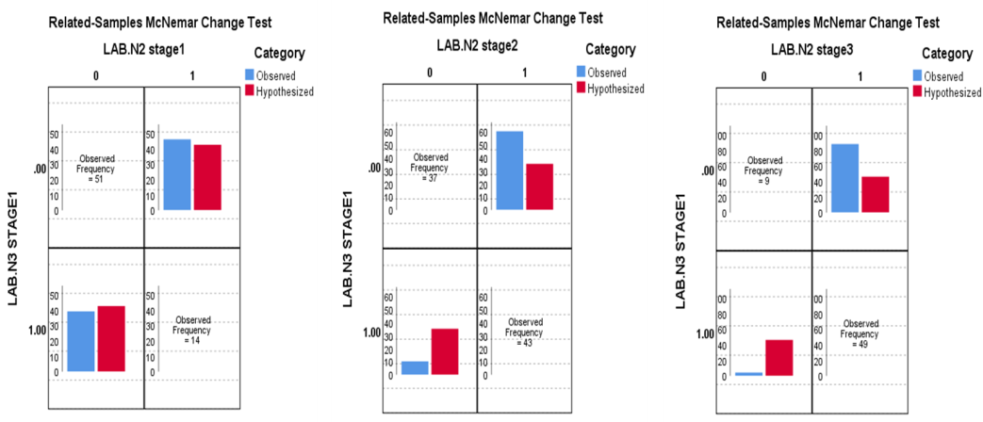Figure.8: Related-Samples McNemar Change Test between GG genotype and normal lumbar T-score(LAB.N1 stage1), osteopenia lumbar T-score(LAB.N1 stage2), osteoporosis lumbar T-score(LAB.N1 stage3).

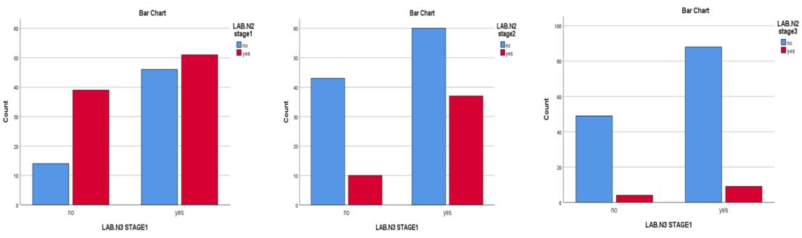
Figure .9: Bar chart to the frequency between normal lumbar T-score(LAB.N1 stage1) osteopenia lumbar T-score(LAB.N1 stage2), osteoporosis lumbar T-score(LAB.N1 stage3) and GGgenotype.

Crosstab(GG genotype and normal lumbar T-score)
Count
 |  | normal lumbar T-score |  |  | Total
 |  | No | yes
GG genotype | no | 14 | 39 |  | 53
 | yes | 46 | 51 |  | 97
Total |  | 60 | 90 |  | 150
Risk Estimate(GG genotype and normal lumbar T-score)
 |  |  |  |  |  | Value |  |  |  | 95% Confidence Interval
 |  |  |  |  |  |  |  |  |  | Lower |  |  | Upper
Odds Ratio for GG genotype (no / yes) |  |  |  |  |  | .398 |  |  |  | .192 |  |  | .825
For cohort normal lumbar T-score = no |  |  |  |  |  | .557 |  |  |  | .339 |  |  | .915
For cohort normal lumbar T-score = yes |  |  |  |  |  | 1.400 |  |  |  | 1.092 |  |  | 1.794
N of Valid Cases |  |  |  |  |  | 150
Crosstab(GG genotype and osteopenia lumbar T-score)
Count
 |  | osteopenia lumbar T-score |  |  | Total
 |  | no | Yes
GG genotype | no | 43 | 10 |  | 53
 | yes | 60 | 37 |  | 97
Total |  | 103 | 47 |  | 150
Risk Estimate(GG genotype and osteopenia lumbar T-score)
 |  | Value |  | 95% Confidence Interval
 |  |  |  | Lower |  |  |  | Upper
Odds Ratio for GG genotype (no / yes) |  | 2.652 |  | 1.190 |  |  |  | 5.906
For cohort osteopenia lumbar T-score = no |  | 1.312 |  | 1.070 |  |  |  | 1.607
For cohort osteopenia lumbar T-score = yes |  | .495 |  | .268 |  |  |  | .913
N of Valid Cases |  | 150
Crosstab(GG genotype and osteoporosis lumbar T-score)
Count
 |  | osteoporosis lumbar T-score |  |  |  |  |  |  |  |  |  | Total
 |  | no |  |  |  |  |  |  | yes
GG genotype | no | 49 |  |  |  |  |  |  | 4 |  |  | 53
 | yes | 88 |  |  |  |  |  |  | 9 |  |  | 97
Total |  | 137 |  |  |  |  |  |  | 13 |  |  | 150
Risk Estimate(GG genotype and osteoporosis lumbar T-score)
 |  |  |  |  |  |  | Value |  |  |  | 95% Confidence Interval
 |  |  |  |  |  |  |  |  |  |  | Lower |  |  | Upper
Odds Ratio for GG genotype (no / yes) |  |  |  |  |  |  | 1.253 |  |  |  | .367 |  |  | 4.280
For cohort osteoporosis lumbar T-score = no |  |  |  |  |  |  | 1.019 |  |  |  | .922 |  |  | 1.126
For cohort osteoporosis lumbar T-score = yes |  |  |  |  |  |  | .813 |  |  |  | .263 |  |  | 2.516
N of Valid Cases |  |  |  |  |  |  | 150
Table.14: Results of cross-tab and risk estimate tests were used to identify the odd risk for lumbar T-score values when GG genotype is absence or existed.

Chi-Square Tests( GG genotype and normal lumbar T-score)
 | Value |  | df |  | Asymptotic Significance (2-sided) |  |  | Exact Sig. (2-sided) |  | Exact Sig. (1-sided)
Pearson Chi-Square | 6.302ª |  | 1 |  | .012
a. 0 cells (0.0%) have expected count less than 5. The minimum expected count is 21.20.
b. Computed only for a 2x2 table
Chi-Square Tests( GG genotype and osteopenia lumbar T-score)
 |  | Value |  |  | df | Asymptotic Significance (2-sided) |  |  | Exact Sig. (2-sided) |  |  | Exact Sig. (1-sided)
Pearson Chi-Square |  | 5.919ª |  |  | 1 | .015
a. 0 cells (0.0%) have expected count less than 5. The minimum expected count is 16.61.
b. Computed only for a 2x2 table
Chi-Square Tests (GG genotype and osteoporosis lumbar T-score)
 |  |  |  | Value |  | df | Asymptotic Significance (2-sided) |  | Exact Sig. (2-sided) |  | Exact Sig. (1-sided)
Pearson Chi-Square |  |  |  | .130ª |  | 1 | .719
a. 1 cells (25.0%) have expected count less than 5. The minimum expected count is 4.59.
b. Computed only for a 2x2 table
Table.15: Results of Chi-Square Tests for GG genotype and lumbar T-score values

3.2.CC genotype results:
Hypothesis Test Summary
 | Null Hypothesis | Test | Sig. | Decision
 | The distributions of different values across CC genotype,normal lumbar T-score are equally likely. | Related-Samples McNemar Change Test | .000 | Reject the null hypothesis.
 | The distributions of different values across CC genotypes and osteopenia lumbar T-score are equally likely. | Related-Samples McNemar Change Test | .001 | Reject the null hypothesis.
 | The distributions of different values across CC genotype and osteoporosis lumbar T-score are equally likely. | Related-Samples McNemar Change Test | .265 | Retain the null hypothesis.
Asymptotic significances are displayed. The significance level is .050.
Table.16: Observation hypothesis Test Summary for CC genotype, lumbar T-score values

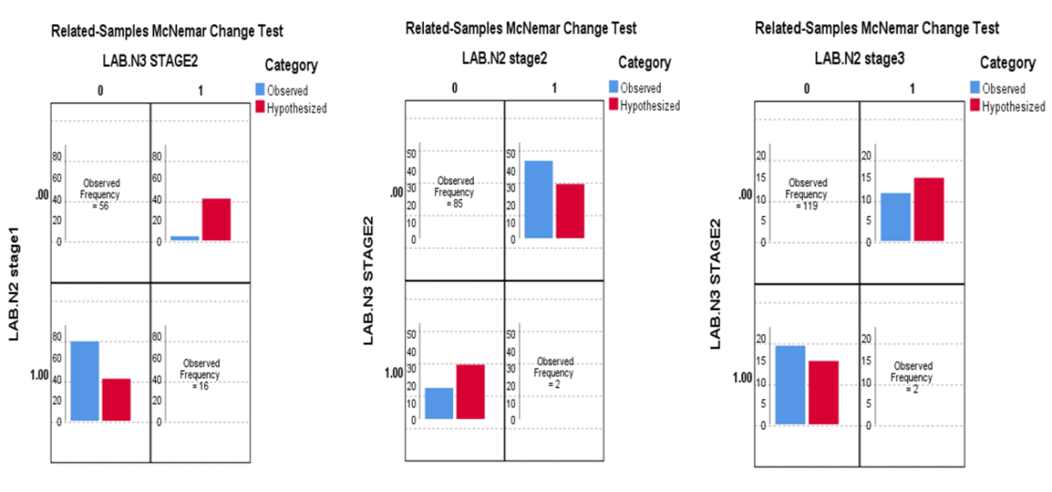Figure.10: Related-Samples McNemar Change Test between CC genotype and normal lumbar T-score(LAB.N1 stage1), osteopenia lumbar T-score(LAB.N1 stage2), osteoporosis lumbar T-score(LAB.N1 stage3).

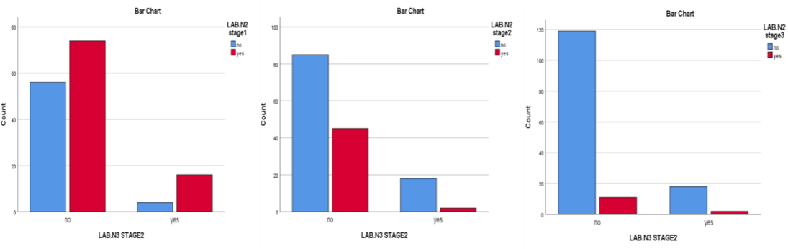
Figure.11: Bar chart to the frequency between normal lumbar T-score(LAB.N1 stage1), osteopenia lumbar T-score(LAB.N1 stage2), osteoporosis lumbar T-score(LAB.N1 stage3) and CC genotype.

Crosstab (CC genotype and normal lumbar T-score)
Count
 |  | normal lumbar T-score |  |  |  | Total
 |  | no |  | yes
CC genotype | no | 56 |  | 74 |  | 130
 | yes | 4 |  | 16 |  | 20
Total |  | 60 |  | 90 |  | 150
Risk Estimate(CC genotype and normal lumbar T-score)
 |  |  | Value |  | 95% Confidence Interval
 |  |  |  |  | Lower |  | Upper
Odds Ratio for CC genotype (no / yes) |  |  | 3.027 |  | .959 |  | 9.554
For cohort normal lumbar T-score = no |  |  | 2.154 |  | .877 |  | 5.290
For cohort normal lumbar T-score = yes |  |  | .712 |  | .546 |  | .928
N of Valid Cases |  |  | 150
Crosstab (CC genotype and osteopenia lumbar T-score)
Count
 |  | osteopenia lumbar T-score |  |  |  | Total
 |  | no |  | Yes
CC genotype | no | 85 |  | 45 |  | 130
 | yes | 18 |  | 2 |  | 20
Total |  | 103 |  | 47 |  | 150
Risk Estimate(CC genotype and osteopenia lumbar T-score)
 |  |  | Value |  | 95% Confidence Interval
 |  |  |  |  | Lower |  | Upper
Odds Ratio for CC genotype (no / yes) |  |  | .210 |  | .047 |  | .945
For cohort osteopenia lumbar T-score = no |  |  | .726 |  | .599 |  | .881
For cohort osteopenia lumbar T-score = yes |  |  | 3.462 |  | .910 |  | 13.165
N of Valid Cases |  |  | 150
Crosstab (CC genotype and osteoporosis lumbar T-score)
Count
 |  | osteoporosis lumbar T-score |  |  |  | Total
 |  | no |  | yes
CC genotype | no | 119 |  | 11 |  | 130
 | yes | 18 |  | 2 |  | 20
Total |  | 137 |  | 13 |  | 150
Risk Estimate(CC genotype and osteoporosis lumbar T-score)
 |  |  | Value |  | 95% Confidence Interval
 |  |  |  |  | Lower |  | Upper
Odds Ratio for CCgenotype (no / yes) |  |  | 1.202 |  | .246 |  | 5.871
For cohort osteoporosis lumbar T-score = no |  |  | 1.017 |  | .871 |  | 1.188
For cohort osteoporosis lumbar T-score = yes |  |  | .846 |  | .202 |  | 3.540
N of Valid Cases |  |  | 150
Table.17: Results of cross-tab and risk estimate tests were used to identify the odd risk for lumbar T-score values when CC genotype is absence or existed.
Chi-Square Tests(CC genotype, normal lumbar T-score)
 | Value | Df | Asymptotic Significance (2-sided) | Exact Sig. (2-sided) | Exact Sig. (1-sided)
Pearson Chi-Square | 3.846ª | 1 | .050
a. 0 cells (0.0%) have expected count less than 5. The minimum expected count is 8.00.
b. Computed only for a 2x2 table
Chi-Square Tests CC, osteopenia
 | Value | df | Asymptotic Significance (2-sided) | Exact Sig. (2-sided) | Exact Sig. (1-sided)
Pearson Chi-Square | 7.731ª | 1 | .005
a. 0 cells (0.0%) have expected count less than 5. The minimum expected count is 6.40.
b. Computed only for a 2x2 table
Chi-Square Tests CC. osteoporosis
 | Value | df | Asymptotic Significance (2-sided) | Exact Sig. (2-sided) | Exact Sig. (1-sided)
Pearson Chi-Square | .204ª | 1 | .651
a. 1 cells (25.0%) have expected count less than 5. The minimum expected count is 3.73.
b. Computed only for a 2x2 table
Table.18: Results of Chi-Square Tests for CC genotype and lumbar T-score values

3.3.GC genotype results:
Hypothesis Test Summary
 | Null Hypothesis | Test | Sig. |  | Decision
 | The distributions of different values across GC genotype and normal lumbar T-score are equally likely. | Related-Samples McNemar Change Test | .000 |  | Reject the null hypothesis.
 | The distributions of different values across GC genotype and osteopenia lumbar T-score are equally likely. | Related-Samples McNemar Change Test | .104 | Retain the null hypothesis.
 | The distributions of different values across GC genotype and osteoporosis lumbar T-score are equally likely. | Related-Samples McNemar Change Test | .003 |  | Reject the null hypothesis.
Asymptotic significances are displayed. The significance level is .050.
Table.19: Observation hypothesis Test Summary for GC genotype, lumbar T-score values

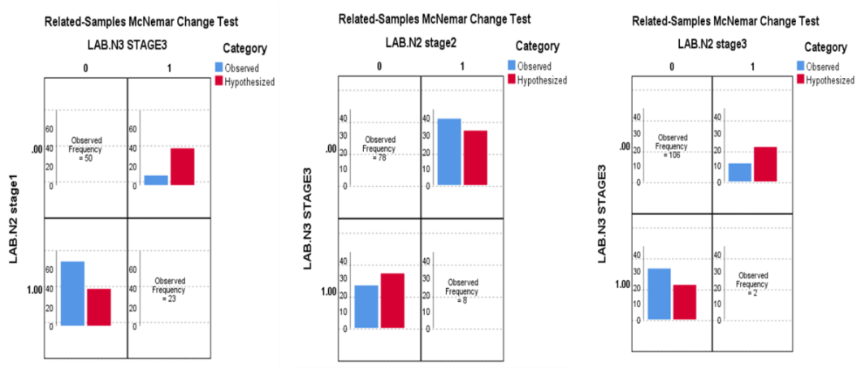Figure.12: Related-Samples McNemar Change Test between GC genotype and normal lumbar T-score(LAB.N1 stage1), osteopenia lumbar T-score(LAB.N1 stage2), osteoporosis lumbar T-score(LAB.N1 stage3)

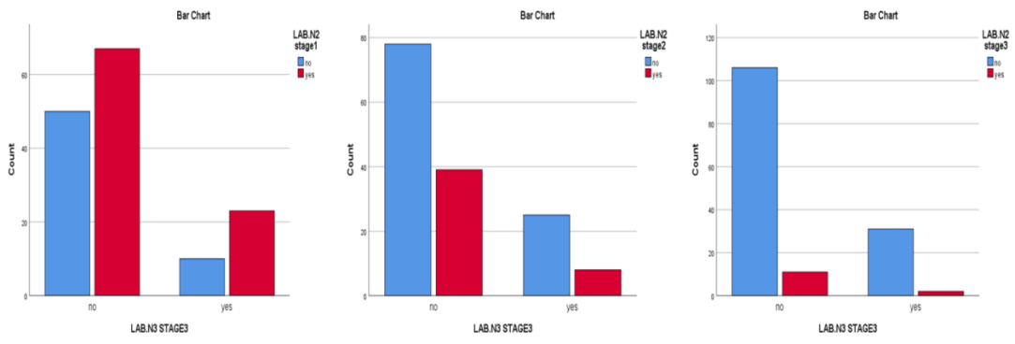Figure.13: Bar chart to the frequency between normal lumbar T-score(LAB.N1 stage1) osteopenia lumbar T-score(LAB.N1 stage2), osteoporosis lumbar T-score(LAB.N1 stage3) and GC genotype

Crosstab (GC genotype, normal lumbar T-score)
Count
 |  | normal lumbar T-score |  |  |  |  |  |  | Total
 |  | no |  |  |  | yes
GC genotype | no | 50 |  |  |  | 67 |  |  | 117
 | yes | 10 |  |  |  | 23 |  |  | 33
Total |  | 60 |  |  |  | 90 |  |  | 150
Risk Estimate(GC genotype, normal lumbar T-score)
 |  |  | Value |  |  |  | 95% Confidence Interval
 |  |  |  |  |  |  | Lower |  |  |  | Upper
Odds Ratio for GC genotype (no / yes) |  |  | 1.716 |  |  |  | .750 |  |  |  | 3.928
For cohort normal lumbar T-score = no |  |  | 1.410 |  |  |  | .807 |  |  |  | 2.465
For cohort normal lumbar T-score = yes |  |  | .822 |  |  |  | .625 |  |  |  | 1.081
N of Valid Cases |  |  | 150
Crosstab (GC genotype, osteopenia lumbar T-score)
Count
 |  | osteopenia lumbar T-score |  |  |  |  |  |  | Total
 |  | no |  |  |  | Yes
GC genotype | no | 78 |  |  |  | 39 |  |  | 117
 | yes | 25 |  |  |  | 8 |  |  | 33
Total |  | 103 |  |  |  | 47 |  |  | 150
Risk Estimate(GC genotype, osteopenia lumbar T-score)
 |  |  |  | Value |  |  |  | 95% Confidence Interval
 |  |  |  |  |  |  |  | Lower |  |  |  | Upper
Odds Ratio for GC genotype (no / yes) |  |  |  | .640 |  |  |  | .264 |  |  |  | 1.549
For cohort osteopenia lumbar T-score = no |  |  |  | .880 |  |  |  | .698 |  |  |  | 1.109
For cohort osteopenia lumbar T-score = yes |  |  |  | 1.375 |  |  |  | .714 |  |  |  | 2.648
N of Valid Cases |  |  |  | 150
Crosstab (GC genotype, osteoporosis lumbar T-score)
Count
 |  | osteoporosis lumbar T-score |  |  |  |  |  |  | Total
 |  | no |  |  |  | yes
GC genotype | no | 106 |  |  |  | 11 |  |  | 117
 | yes | 31 |  |  |  | 2 |  |  | 33
Total |  | 137 |  |  |  | 13 |  |  | 150
Risk Estimate(GC genotype, osteoprosis lumbar T-score)
 |  |  |  |  | Value |  |  |  |  | 95% Confidence Interval
 |  |  |  |  |  |  |  |  |  | Lower |  | Upper
Odds Ratio for GC genotype (no / yes) |  |  |  |  | .622 |  |  |  |  | .131 |  | 2.955
For cohort osteoporosis lumbar T-score = no |  |  |  |  | .964 |  |  |  |  | .869 |  | 1.071
For cohort osteoporosis lumbar T-score = yes |  |  |  |  | 1.551 |  |  |  |  | .362 |  | 6.655
N of Valid Cases |  |  |  |  | 150
Table.20: Results of cross-tab and risk estimate tests were used to identify the odd risk for lumbar T-score values when LRP5G171R genotype is absence or existed.

Chi-Square Tests(GC genotype, normal lumbar T-score)
 | Value |  |  | df | Asymptotic Significance (2-sided) |  |  | Exact Sig. (2-sided) |  | Exact Sig. (1-sided)
Pearson Chi-Square | 1.658ª |  |  | 1 | .198
a. 0 cells (0.0%) have expected count less than 5. The minimum expected count is 13.20.
b. Computed only for a 2x2 table
Chi-Square Tests(GC genotype, osteopenia lumbar T-score)
 |  |  | Value |  |  | df | Asymptotic Significance (2-sided) |  | Exact Sig. (2-sided) |  | Exact Sig. (1-sided)
Pearson Chi-Square |  |  | .989ª |  |  | 1 | .320
a. 0 cells (0.0%) have expected count less than 5. The minimum expected count is 10.34.
b. Computed only for a 2x2 table
Chi-Square Tests(GC genotype, osteoporosis lumbar T-score)
 |  | Value |  |  |  | Df | Asymptotic Significance (2-sided) |  | Exact Sig. (2-sided) |  | Exact Sig. (1-sided)
Pearson Chi-Square |  | .363ª |  |  |  | 1 | .547
a. 1 cells (25.0%) have expected count less than 5. The minimum expected count is 2.86.
b. Computed only for a 2x2 table
Table .21: Results of Chi-Square Tests for GC genotype and lumbar T-score values

4.Statistical applications Mild OI, LOW BMD
Related-Samples McNemar Change Test was used to exams the variant significant under 95% confidence level (α ≤ .050) and studying a null hypothesis interested in mild OI of distribution across low BMD. Chi-Square Tests was used to estimate the correlation between mild OI and each of lpw BMD(osteopenia, osteoporosis) under 95% confidence (α ≤ .050)

Variables in the Equation
 |  |  | B |  | S.E. | Wald |  | df |  | Sig. | Exp(B)
Step 1ª |  | mild(1) | 1.758 |  | .407 | 18.612 |  | 1 |  | .000 | 5.800
 |  | Constant | .000 |  | .221 | .000 |  | 1 |  | 1.000 | 1.000
Variable(s) entered on step 1: STAGE(2.3) "N1 and/or N2.
Table 3. Observation hypothesis Test Summary
 | Null Hypothesis |  |  | Test |  |  | Sig. |  | Decision
1 | The distributions of different values across mild and STAGE(2.3) "N1 and/or N2 are equally likely. |  |  | Related-Samples McNemar Change Test |  |  | .108 |  | Retain the null hypothesis.
Asymptotic significances are displayed. The significance level is .050.
Table 22. Variables in the Equation for mild OI * OSTEOPENIA , OSTEOPROSIS binary logistic regression
 | Value | df | Asymptotic Significance (2-sided) | Exact Sig. (2-sided) | Exact Sig. (1-sided)
Pearson Chi-Square | 20.635ª | 1 | .000
Continuity Correction^{b} | 19.093 | 1 | .000
Likelihood Ratio | 21.845 | 1 | .000
Fisher's Exact Test |  |  |  | .000 | .000
Linear-by-Linear Association | 20.498 | 1 | .000
N of Valid Cases | 150
a. 0 cells (0.0%) have expected count less than 5. The minimum expected count is 23.12.
b. Computed only for a 2x2 table
Table 23. mild OI * (OSTEOPENIA, OSTEOPROSIS) Chi-Square Tests

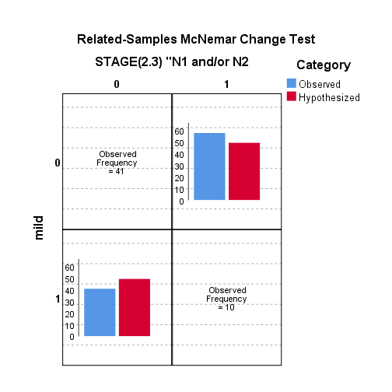
Figure 14. Related-Samples McNemar Change Test between mild and mild OI/ Low BMD( osteopenia=stage2, osteoporosis= stage 3

5.Statistical applications (MILD OI, LOW BMD) with parameters
Multinomial logistic regression was used to estimate the predictability under 95% confidence level (α ≤ .050) . Odds ratio test and chi –square test to estimate the relationship of (mild OI, low BMD) with parameters under 95% confidence (α ≤ .050).
1.5. Variables in the Equation for parameter * mild OI + low BMD binary logistic regression

Variables in the Equation
 |  | B | S.E. | Wald | df | Sig. | Exp(B) | 95% C.I.for EXP(B)
 |  |  |  |  |  |  |  | Lower | Upper
Step 1ª | [40-59] weight group | 2.868 | 1.320 | 4.717 | 1 | .030 | 17.597 | 1.323 | 234.079
 | [60-79] weight group | .934 | .933 | 1.001 | 1 | .317 | 2.544 | .409 | 15.838
 | [80-99] weight group | 1.686 | 1.000 | 2.841 | 1 | .092 | 5.397 | .760 | 38.334
 | [150-159] height group | .069 | 1.128 | .004 | 1 | .951 | 1.071 | .117 | 9.782
 | [160-169] height group | .239 | 1.029 | .054 | 1 | .816 | 1.270 | .169 | 9.549
 | 18.5 ≥ BMI group | -2.590 | 2.039 | 1.613 | 1 | .204 | .075 | .001 | 4.083
 | [18.5-24.9] BMI group | -1.534 | 1.462 | 1.100 | 1 | .294 | .216 | .012 | 3.790
 | [25-29.9] BMI group | -.185 | 1.270 | .021 | 1 | .884 | .831 | .069 | 10.017
 | [30-34.9] BMI group | -.441 | 1.172 | .142 | 1 | .706 | .643 | .065 | 6.391
 | [40-50] age group | .501 | 1.358 | .136 | 1 | .712 | 1.650 | .115 | 23.618
 | ]50-60] age group | 1.668 | 1.332 | 1.567 | 1 | .211 | 5.299 | .389 | 72.156
 | ]60-70] age group | 2.839 | 1.329 | 4.563 | 1 | .033 | 17.107 | 1.264 | 231.567
 | {11] first of Menstrual period group | 1.182 | .982 | 1.450 | 1 | .229 | 3.262 | .476 | 22.355
 | [12] first of Menstrual period group | -.457 | 1.015 | .203 | 1 | .653 | .633 | .087 | 4.628
 | [13] first of Menstrual period group | .884 | .944 | .876 | 1 | .349 | 2.419 | .380 | 15.389
 | [14] first of Menstrual period group | .467 | .925 | .255 | 1 | .614 | 1.595 | .260 | 9.772
 | [40-42] end and pre- end of Menstrual period group | .237 | .789 | .091 | 1 | .763 | 1.268 | .270 | 5.950
 | [43-45] end and pre- end of Menstrual period group | .677 | .789 | .735 | 1 | .391 | 1.967 | .419 | 9.237
 | [46-48] end and pre- end of Menstrual period group | -.040 | .726 | .003 | 1 | .956 | .961 | .231 | 3.988
 | [49-51] end and pre- end of Menstrual period group | -1.103 | .755 | 2.134 | 1 | .144 | .332 | .076 | 1.458
 | Constant | -3.591 | 1.544 | 5.410 | 1 | .020 | .028
a. Variable(s) entered on step 1: [40-59] weight group, [60-79] weight group, [80-99] weight group, [150-159] height group, [160-169] height group, 18.5 ≥ BMI group, [18.5-24.9] BMI group, [25-29.9] BMI group, [30-34.9] BMI group, [40-50] age group, ]50-60] age group, ]60-70] age group, {11] first of Menstrual period group, [12] first of Menstrual period group, [13] first of Menstrual period group, [14] first of Menstrual period group, [40-42] end and pre- end of Menstrual period group, [43-45] end and pre- end of Menstrual period group, [46-48] end and pre- end of Menstrual period group, [49-51] end and pre- end of Menstrual period group.
Table 24. Variables in the Equation for parameter * mild OI + low BMD binary logistic regression

2.5. Results of Odd Ratio test for mildOI / low BMD (osteopenia = stage2, osteoporosis= stage3)
Crosstab
 |  |  | [170-179] height group |  | Total
 |  |  | No | Yes
mild+/ stage2 - 3 | No | Count | 87 | 22 | 109
 |  | % within mild+/ stage2 - 3 | 79.8% | 20.2% | 100.0%
 | Yes | Count | 39 | 2 | 41
 |  | % within mild+/ stage2 - 3 | 95.1% | 4.9% | 100.0%
Total |  | Count | 126 | 24 | 150
 |  | % within mild+/ stage2 - 3 | 84.0% | 16.0% | 100.0%

Risk Estimate
 | Value | 95% Confidence Interval
 |  | Lower | Upper
Odds Ratio for mild+/ stage2 - 3 (No / Yes) | .203 | .045 | .905
For cohort [170-179] height group = No | .839 | .746 | .943
For cohort [170-179] height group = Yes | 4.138 | 1.018 | 16.817
N of Valid Cases | 150

Crosstab
 |  |  | BMI ≥ 35 |  | Total
 |  |  | No | Yes
mild+/ stage2 - 3 | No | Count | 101 | 8 | 109
 |  | % within mild+/ stage2 - 3 | 92.7% | 7.3% | 100.0%
 | Yes | Count | 39 | 2 | 41
 |  | % within mild+/ stage2 - 3 | 95.1% | 4.9% | 100.0%
Total |  | Count | 140 | 10 | 150
 |  | % within mild+/ stage2 - 3 | 93.3% | 6.7% | 100.0%

Risk Estimate
 | Value | 95% Confidence Interval
 |  | Lower | Upper
Odds Ratio for mild+/ stage2 - 3 (No / Yes) | .647 | .132 | 3.184
For cohort BMI ≥ 35 = No | .974 | .893 | 1.063
For cohort BMI ≥ 35 = Yes | 1.505 | .333 | 6.793
N of Valid Cases | 150

Crosstab
 |  |  | ]70-80] age group |  | Total
 |  |  | No | Yes
mild+/ stage2 - 3 | No | Count | 91 | 18 | 109
 |  | % within mild+/ stage2 - 3 | 83.5% | 16.5% | 100.0%
 | Yes | Count | 40 | 1 | 41
 |  | % within mild+/ stage2 - 3 | 97.6% | 2.4% | 100.0%
Total |  | Count | 131 | 19 | 150
 |  | % within mild+/ stage2 - 3 | 87.3% | 12.7% | 100.0%

Risk Estimate
 | Value | 95% Confidence Interval
 |  | Lower | Upper
Odds Ratio for mild+/ stage2 - 3 (No / Yes) | .126 | .016 | .980
For cohort ]70-80] age group = No | .856 | .777 | .942
For cohort ]70-80] age group = Yes | 6.771 | .934 | 49.107
N of Valid Cases | 150

Crosstab
 |  |  | [15] first of Menstrual period group |  |  |  | Total
 |  |  | No |  | Yes
mild+/ stage2 - 3 | No | Count |  | 91 |  | 18 |  | 109
 |  | % within mild+/ stage2 - 3 |  | 83.5% |  | 16.5% |  | 100.0%
 | Yes | Count |  | 38 |  | 3 |  | 41
 |  | % within mild+/ stage2 - 3 |  | 92.7% |  | 7.3% |  | 100.0%
Total |  | Count | 129 |  | 21 |  | 150
 |  | % within mild+/ stage2 - 3 | 86.0% |  | 14.0% |  | 100.0%

Risk Estimate
 | Value | 95% Confidence Interval
 |  | Lower | Upper
Odds Ratio for mild+/ stage2 - 3 (No / Yes) | .399 | .111 | 1.435
For cohort [15] first of Menstrual period group = No | .901 | .799 | 1.015
For cohort [15] first of Menstrual period group = Yes | 2.257 | .702 | 7.259
N of Valid Cases | 150

Crosstab
 |  |  | [52-54] end and pre- end of Menstrual period group |  | Total
 |  |  | No | Yes
mild+/ stage2 - 3 | No | Count | 83 | 26 | 109
 |  | % within mild+/ stage2 - 3 | 76.1% | 23.9% | 100.0%
 | Yes | Count | 34 | 7 | 41
 |  | % within mild+/ stage2 - 3 | 82.9% | 17.1% | 100.0%
Total |  | Count | 117 | 33 | 150
 |  | % within mild+/ stage2 - 3 | 78.0% | 22.0% | 100.0%

Risk Estimate
 | Value | 95% Confidence Interval
 |  | Lower | Upper
Odds Ratio for mild+/ stage2 - 3 (No / Yes) | .657 | .261 | 1.658
For cohort [52-54] end and pre- end of Menstrual period group = No | .918 | .771 | 1.093
For cohort [52-54] end and pre- end of Menstrual period group = Yes | 1.397 | .658 | 2.968
N of Valid Cases | 150

Table25: results of ODD ratio test for mildOI / low BMD (osteopenia = stage2, osteoporosis= stage3)

3.5. Mild OI+/ low BMD(osteopenia =stage2, osteoporosis= stage3) * parameters groups(chi-square test)

Crosstab
 |  |  | [40-59] weight group |  | Total
 |  |  | No | Yes
mild+/ stage2 - 3 | No | Count | 90 | 19 | 109
 |  | % within mild+/ stage2 - 3 | 82.6% | 17.4% | 100.0%
 | Yes | Count | 30 | 11 | 41
 |  | % within mild+/ stage2 - 3 | 73.2% | 26.8% | 100.0%
Total |  | Count | 120 | 30 | 150
 |  | % within mild+/ stage2 - 3 | 80.0% | 20.0% | 100.0%

Chi-Square Tests
 | Value | df | Asymptotic Significance (2-sided) | Exact Sig. (2-sided) | Exact Sig. (1-sided)
Pearson Chi-Square | 1.645ª | 1 | .200
Continuity Correction^{b} | 1.110 | 1 | .292
Likelihood Ratio | 1.574 | 1 | .210
Fisher's Exact Test |  |  |  | .252 | .146
Linear-by-Linear Association | 1.634 | 1 | .201
N of Valid Cases | 150
a. 0 cells (0.0%) have expected count less than 5. The minimum expected count is 8.20.
b. Computed only for a 2x2 table

Crosstab
 |  |  | [60-79] weight group |  | Total
 |  |  | No | Yes
mild+/ stage2 - 3 | No | Count | 59 | 50 | 109
 |  | % within mild+/ stage2 - 3 | 54.1% | 45.9% | 100.0%
 | Yes | Count | 19 | 22 | 41
 |  | % within mild+/ stage2 - 3 | 46.3% | 53.7% | 100.0%
Total |  | Count | 78 | 72 | 150
 |  | % within mild+/ stage2 - 3 | 52.0% | 48.0% | 100.0%

Chi-Square Tests
 | Value | df | Asymptotic Significance (2-sided) | Exact Sig. (2-sided) | Exact Sig. (1-sided)
Pearson Chi-Square | .724ª | 1 | .395
Continuity Correction^{b} | .445 | 1 | .505
Likelihood Ratio | .724 | 1 | .395
Fisher's Exact Test |  |  |  | .464 | .252
Linear-by-Linear Association | .719 | 1 | .396
N of Valid Cases | 150
a. 0 cells (0.0%) have expected count less than 5. The minimum expected count is 19.68.
b. Computed only for a 2x2 table

Crosstab
 |  |  | [80-99] weight group |  | Total
 |  |  | No | Yes
mild+/ stage2 - 3 | No | Count | 103 | 6 | 109
 |  | % within mild+/ stage2 - 3 | 94.5% | 5.5% | 100.0%
 | Yes | Count | 37 | 4 | 41
 |  | % within mild+/ stage2 - 3 | 90.2% | 9.8% | 100.0%
Total |  | Count | 140 | 10 | 150
 |  | % within mild+/ stage2 - 3 | 93.3% | 6.7% | 100.0%

Chi-Square Tests
 | Value | df | Asymptotic Significance (2-sided) | Exact Sig. (2-sided) | Exact Sig. (1-sided)
Pearson Chi-Square | .865ª | 1 | .352
Continuity Correction^{b} | .317 | 1 | .573
Likelihood Ratio | .806 | 1 | .369
Fisher's Exact Test |  |  |  | .462 | .276
Linear-by-Linear Association | .860 | 1 | .354
N of Valid Cases | 150
a. 1 cells (25.0%) have expected count less than 5. The minimum expected count is 2.73.
b. Computed only for a 2x2 table

Crosstab
 |  |  | [150-159] height group |  | Total
 |  |  | No | Yes
mild+/ stage2 - 3 | No | Count | 79 | 30 | 109
 |  | % within mild+/ stage2 - 3 | 72.5% | 27.5% | 100.0%
 | Yes | Count | 26 | 15 | 41
 |  | % within mild+/ stage2 - 3 | 63.4% | 36.6% | 100.0%
Total |  | Count | 105 | 45 | 150
 |  | % within mild+/ stage2 - 3 | 70.0% | 30.0% | 100.0%

Chi-Square Tests
 | Value | df | Asymptotic Significance (2-sided) | Exact Sig. (2-sided) | Exact Sig. (1-sided)
Pearson Chi-Square | 1.165ª | 1 | .280
Continuity Correction^{b} | .774 | 1 | .379
Likelihood Ratio | 1.140 | 1 | .286
Fisher's Exact Test |  |  |  | .320 | .189
Linear-by-Linear Association | 1.157 | 1 | .282
N of Valid Cases | 150
a. 0 cells (0.0%) have expected count less than 5. The minimum expected count is 12.30.
b. Computed only for a 2x2 table

Crosstab
 |  |  | [160-169] height group |  | Total
 |  |  | No | Yes
mild+/ stage2 - 3 | No | Count | 52 | 57 | 109
 |  | % within mild+/ stage2 - 3 | 47.7% | 52.3% | 100.0%
 | Yes | Count | 17 | 24 | 41
 |  | % within mild+/ stage2 - 3 | 41.5% | 58.5% | 100.0%
Total |  | Count | 69 | 81 | 150
 |  | % within mild+/ stage2 - 3 | 46.0% | 54.0% | 100.0%

Chi-Square Tests
 | Value | df | Asymptotic Significance (2-sided) | Exact Sig. (2-sided) | Exact Sig. (1-sided)
Pearson Chi-Square | .467ª | 1 | .494
Continuity Correction^{b} | .250 | 1 | .617
Likelihood Ratio | .469 | 1 | .493
Fisher's Exact Test |  |  |  | .582 | .309
Linear-by-Linear Association | .464 | 1 | .496
N of Valid Cases | 150
a. 0 cells (0.0%) have expected count less than 5. The minimum expected count is 18.86.
b. Computed only for a 2x2 table

Crosstab
 |  |  | [170-179] height group |  | Total
 |  |  | No | Yes
mild+/ stage2 - 3 | No | Count | 87 | 22 | 109
 |  | % within mild+/ stage2 - 3 | 79.8% | 20.2% | 100.0%
 | Yes | Count | 39 | 2 | 41
 |  | % within mild+/ stage2 - 3 | 95.1% | 4.9% | 100.0%
Total |  | Count | 126 | 24 | 150
 |  | % within mild+/ stage2 - 3 | 84.0% | 16.0% | 100.0%

Chi-Square Tests
 | Value | df | Asymptotic Significance (2-sided) | Exact Sig. (2-sided) | Exact Sig. (1-sided)
Pearson Chi-Square | .358ª | 1 | .550
Continuity Correction^{b} | .017 | 1 | .896
Likelihood Ratio | .395 | 1 | .530
Fisher's Exact Test |  |  |  | 1.000 | .477
Linear-by-Linear Association | .356 | 1 | .551
N of Valid Cases | 150
a. 2 cells (50.0%) have expected count less than 5. The minimum expected count is 1.64.
b. Computed only for a 2x2 table

Crosstab
 |  |  | [18.5-24.9] BMI group |  | Total
 |  |  | No | Yes
mild+/ stage2 - 3 | No | Count | 77 | 32 | 109
 |  | % within mild+/ stage2 - 3 | 70.6% | 29.4% | 100.0%
 | Yes | Count | 28 | 13 | 41
 |  | % within mild+/ stage2 - 3 | 68.3% | 31.7% | 100.0%
Total |  | Count | 105 | 45 | 150
 |  | % within mild+/ stage2 - 3 | 70.0% | 30.0% | 100.0%

Chi-Square Tests
 | Value | df | Asymptotic Significance (2-sided) | Exact Sig. (2-sided) | Exact Sig. (1-sided)
Pearson Chi-Square | .078ª | 1 | .780
Continuity Correction^{b} | .006 | 1 | .936
Likelihood Ratio | .078 | 1 | .780
Fisher's Exact Test |  |  |  | .842 | .463
Linear-by-Linear Association | .078 | 1 | .780
N of Valid Cases | 150
a. 0 cells (0.0%) have expected count less than 5. The minimum expected count is 12.30.
b. Computed only for a 2x2 table

Crosstab
 |  |  | [25-29.9] BMI group |  | Total
 |  |  | No | Yes
mild+/ stage2 - 3 | No | Count | 67 | 42 | 109
 |  | % within mild+/ stage2 - 3 | 61.5% | 38.5% | 100.0%
 | Yes | Count | 22 | 19 | 41
 |  | % within mild+/ stage2 - 3 | 53.7% | 46.3% | 100.0%
Total |  | Count | 89 | 61 | 150
 |  | % within mild+/ stage2 - 3 | 59.3% | 40.7% | 100.0%

Chi-Square Tests
 | Value | df | Asymptotic Significance (2-sided) | Exact Sig. (2-sided) | Exact Sig. (1-sided)
Pearson Chi-Square | .753ª | 1 | .386
Continuity Correction^{b} | .464 | 1 | .496
Likelihood Ratio | .748 | 1 | .387
Fisher's Exact Test |  |  |  | .457 | .247
Linear-by-Linear Association | .748 | 1 | .387
N of Valid Cases | 150
a. 0 cells (0.0%) have expected count less than 5. The minimum expected count is 16.67.
b. Computed only for a 2x2 table
Crosstab
 |  |  | [30-34.9] BMI group |  | Total
 |  |  | No | Yes
mild+/ stage2 - 3 | No | Count | 87 | 22 | 109
 |  | % within mild+/ stage2 - 3 | 79.8% | 20.2% | 100.0%
 | Yes | Count | 35 | 6 | 41
 |  | % within mild+/ stage2 - 3 | 85.4% | 14.6% | 100.0%
Total |  | Count | 122 | 28 | 150
 |  | % within mild+/ stage2 - 3 | 81.3% | 18.7% | 100.0%

Chi-Square Tests
 | Value | df | Asymptotic Significance (2-sided) | Exact Sig. (2-sided) | Exact Sig. (1-sided)
Pearson Chi-Square | .604ª | 1 | .437
Continuity Correction^{b} | .294 | 1 | .588
Likelihood Ratio | .629 | 1 | .428
Fisher's Exact Test |  |  |  | .491 | .300
Linear-by-Linear Association | .600 | 1 | .438
N of Valid Cases | 150
a. 0 cells (0.0%) have expected count less than 5. The minimum expected count is 7.65.
b. Computed only for a 2x2 table

Crosstab
 |  |  | BMI ≥ 35 |  | Total
 |  |  | No | Yes
mild+/ stage2 - 3 | No | Count | 101 | 8 | 109
 |  | % within mild+/ stage2 - 3 | 92.7% | 7.3% | 100.0%
 | Yes | Count | 39 | 2 | 41
 |  | % within mild+/ stage2 - 3 | 95.1% | 4.9% | 100.0%
Total |  | Count | 140 | 10 | 150
 |  | % within mild+/ stage2 - 3 | 93.3% | 6.7% | 100.0%

Chi-Square Tests
 | Value | df | Asymptotic Significance (2-sided) | Exact Sig. (2-sided) | Exact Sig. (1-sided)
Pearson Chi-Square | .290ª | 1 | .590
Continuity Correction^{b} | .029 | 1 | .864
Likelihood Ratio | .308 | 1 | .579
Fisher's Exact Test |  |  |  | .728 | .452
Linear-by-Linear Association | .288 | 1 | .591
N of Valid Cases | 150
a. 1 cells (25.0%) have expected count less than 5. The minimum expected count is 2.73.
b. Computed only for a 2x2 table

Crosstab
 |  |  | [40-50] age group |  | Total
 |  |  | No | Yes
mild+/ stage2 - 3 | No | Count | 77 | 32 | 109
 |  | % within mild+/ stage2 - 3 | 70.6% | 29.4% | 100.0%
 | Yes | Count | 33 | 8 | 41
 |  | % within mild+/ stage2 - 3 | 80.5% | 19.5% | 100.0%
Total |  | Count | 110 | 40 | 150
 |  | % within mild+/ stage2 - 3 | 73.3% | 26.7% | 100.0%

Chi-Square Tests
 | Value | df | Asymptotic Significance (2-sided) | Exact Sig. (2-sided) | Exact Sig. (1-sided)
Pearson Chi-Square | 1.477ª | 1 | .224
Continuity Correction^{b} | 1.016 | 1 | .313
Likelihood Ratio | 1.542 | 1 | .214
Fisher's Exact Test |  |  |  | .301 | .157
Linear-by-Linear Association | 1.467 | 1 | .226
N of Valid Cases | 150
a. 0 cells (0.0%) have expected count less than 5. The minimum expected count is 10.93.
b. Computed only for a 2x2 table

Crosstab
 |  |  | ]50-60] age group |  | Total
 |  |  | No | Yes
mild+/ stage2 - 3 | No | Count | 67 | 42 | 109
 |  | % within mild+/ stage2 - 3 | 61.5% | 38.5% | 100.0%
 | Yes | Count | 23 | 18 | 41
 |  | % within mild+/ stage2 - 3 | 56.1% | 43.9% | 100.0%
Total |  | Count | 90 | 60 | 150
 |  | % within mild+/ stage2 - 3 | 60.0% | 40.0% | 100.0%

Chi-Square Tests
 | Value | df | Asymptotic Significance (2-sided) | Exact Sig. (2-sided) | Exact Sig. (1-sided)
Pearson Chi-Square | .358ª | 1 | .550
Continuity Correction^{b} | .169 | 1 | .681
Likelihood Ratio | .356 | 1 | .551
Fisher's Exact Test |  |  |  | .579 | .339
Linear-by-Linear Association | .356 | 1 | .551
N of Valid Cases | 150
a. 0 cells (0.0%) have expected count less than 5. The minimum expected count is 16.40.
b. Computed only for a 2x2 table

Crosstab
 |  |  | ]60-70] age group |  | Total
 |  |  | No | Yes
mild+/ stage2 - 3 | No | Count | 92 | 17 | 109
 |  | % within mild+/ stage2 - 3 | 84.4% | 15.6% | 100.0%
 | Yes | Count | 27 | 14 | 41
 |  | % within mild+/ stage2 - 3 | 65.9% | 34.1% | 100.0%
Total |  | Count | 119 | 31 | 150
 |  | % within mild+/ stage2 - 3 | 79.3% | 20.7% | 100.0%

Chi-Square Tests
 | Value | df | Asymptotic Significance (2-sided) | Exact Sig. (2-sided) | Exact Sig. (1-sided)
Pearson Chi-Square | 6.253ª | 1 | .012
Continuity Correction^{b} | 5.173 | 1 | .023
Likelihood Ratio | 5.832 | 1 | .016
Fisher's Exact Test |  |  |  | .022 | .013
Linear-by-Linear Association | 6.211 | 1 | .013
N of Valid Cases | 150
a. 0 cells (0.0%) have expected count less than 5. The minimum expected count is 8.47.
b. Computed only for a 2x2 table

Crosstab
 |  |  | ]70-80] age group |  | Total
 |  |  | No | Yes
mild+/ stage2 - 3 | No | Count | 91 | 18 | 109
 |  | % within mild+/ stage2 - 3 | 83.5% | 16.5% | 100.0%
 | Yes | Count | 40 | 1 | 41
 |  | % within mild+/ stage2 - 3 | 97.6% | 2.4% | 100.0%
Total |  | Count | 131 | 19 | 150
 |  | % within mild+/ stage2 - 3 | 87.3% | 12.7% | 100.0%

Chi-Square Tests
 | Value | df | Asymptotic Significance (2-sided) | Exact Sig. (2-sided) | Exact Sig. (1-sided)
Pearson Chi-Square | 5.335ª | 1 | .021
Continuity Correction^{b} | 4.139 | 1 | .042
Likelihood Ratio | 6.914 | 1 | .009
Fisher's Exact Test |  |  |  | .025 | .014
Linear-by-Linear Association | 5.300 | 1 | .021
N of Valid Cases | 150
a. 0 cells (0.0%) have expected count less than 5. The minimum expected count is 5.19.
b. Computed only for a 2x2 table

Crosstab
 |  |  | {11] first of Menstrual period group |  | Total
 |  |  | No | Yes
mild+/ stage2 - 3 | No | Count | 95 | 14 | 109
 |  | % within mild+/ stage2 - 3 | 87.2% | 12.8% | 100.0%
 | Yes | Count | 31 | 10 | 41
 |  | % within mild+/ stage2 - 3 | 75.6% | 24.4% | 100.0%
Total |  | Count | 126 | 24 | 150
 |  | % within mild+/ stage2 - 3 | 84.0% | 16.0% | 100.0%

Chi-Square Tests
 | Value | df | Asymptotic Significance (2-sided) | Exact Sig. (2-sided) | Exact Sig. (1-sided)
Pearson Chi-Square | 2.955ª | 1 | .086
Continuity Correction^{b} | 2.159 | 1 | .142
Likelihood Ratio | 2.763 | 1 | .096
Fisher's Exact Test |  |  |  | .131 | .074
Linear-by-Linear Association | 2.936 | 1 | .087
N of Valid Cases | 150
a. 0 cells (0.0%) have expected count less than 5. The minimum expected count is 6.56.
b. Computed only for a 2x2 table

Crosstab
 |  |  | [12] first of Menstrual period group |  | Total
 |  |  | No | Yes
mild+/ stage2 - 3 | No | Count | 79 | 30 | 109
 |  | % within mild+/ stage2 - 3 | 72.5% | 27.5% | 100.0%
 | Yes | Count | 35 | 6 | 41
 |  | % within mild+/ stage2 - 3 | 85.4% | 14.6% | 100.0%
Total |  | Count | 114 | 36 | 150
 |  | % within mild+/ stage2 - 3 | 76.0% | 24.0% | 100.0%

Chi-Square Tests
 | Value | df | Asymptotic Significance (2-sided) | Exact Sig. (2-sided) | Exact Sig. (1-sided)
Pearson Chi-Square | 2.713ª | 1 | .100
Continuity Correction^{b} | 2.053 | 1 | .152
Likelihood Ratio | 2.917 | 1 | .088
Fisher's Exact Test |  |  |  | .133 | .073
Linear-by-Linear Association | 2.695 | 1 | .101
N of Valid Cases | 150
a. 0 cells (0.0%) have expected count less than 5. The minimum expected count is 9.84.
b. Computed only for a 2x2 table

Crosstab
 |  |  | [13] first of Menstrual period group |  | Total
 |  |  | No | Yes
mild+/ stage2 - 3 | No | Count | 87 | 22 | 109
 |  | % within mild+/ stage2 - 3 | 79.8% | 20.2% | 100.0%
 | Yes | Count | 28 | 13 | 41
 |  | % within mild+/ stage2 - 3 | 68.3% | 31.7% | 100.0%
Total |  | Count | 115 | 35 | 150
 |  | % within mild+/ stage2 - 3 | 76.7% | 23.3% | 100.0%

Chi-Square Tests
 | Value | df | Asymptotic Significance (2-sided) | Exact Sig. (2-sided) | Exact Sig. (1-sided)
Pearson Chi-Square | 2.212ª | 1 | .137
Continuity Correction^{b} | 1.614 | 1 | .204
Likelihood Ratio | 2.121 | 1 | .145
Fisher's Exact Test |  |  |  | .193 | .103
Linear-by-Linear Association | 2.197 | 1 | .138
N of Valid Cases | 150
a. 0 cells (0.0%) have expected count less than 5. The minimum expected count is 9.57.
b. Computed only for a 2x2 table

Crosstab
 |  |  | [14] first of Menstrual period group |  | Total
 |  |  | No | Yes
mild+/ stage2 - 3 | No | Count | 84 | 25 | 109
 |  | % within mild+/ stage2 - 3 | 77.1% | 22.9% | 100.0%
 | Yes | Count | 32 | 9 | 41
 |  | % within mild+/ stage2 - 3 | 78.0% | 22.0% | 100.0%
Total |  | Count | 116 | 34 | 150
 |  | % within mild+/ stage2 - 3 | 77.3% | 22.7% | 100.0%

Chi-Square Tests
 | Value | df | Asymptotic Significance (2-sided) | Exact Sig. (2-sided) | Exact Sig. (1-sided)
Pearson Chi-Square | .016ª | 1 | .898
Continuity Correction^{b} | .000 | 1 | 1.000
Likelihood Ratio | .017 | 1 | .898
Fisher's Exact Test |  |  |  | 1.000 | .543
Linear-by-Linear Association | .016 | 1 | .898
N of Valid Cases | 150
a. 0 cells (0.0%) have expected count less than 5. The minimum expected count is 9.29.
b. Computed only for a 2x2 table

Crosstab
 |  |  | [15] first of Menstrual period group |  | Total
 |  |  | No | Yes
mild+/ stage2 - 3 | No | Count | 91 | 18 | 109
 |  | % within mild+/ stage2 - 3 | 83.5% | 16.5% | 100.0%
 | Yes | Count | 38 | 3 | 41
 |  | % within mild+/ stage2 - 3 | 92.7% | 7.3% | 100.0%
Total |  | Count | 129 | 21 | 150
 |  | % within mild+/ stage2 - 3 | 86.0% | 14.0% | 100.0%

Chi-Square Tests
 | Value | df | Asymptotic Significance (2-sided) | Exact Sig. (2-sided) | Exact Sig. (1-sided)
Pearson Chi-Square | 2.093ª | 1 | .148
Continuity Correction^{b} | 1.399 | 1 | .237
Likelihood Ratio | 2.340 | 1 | .126
Fisher's Exact Test |  |  |  | .191 | .115
Linear-by-Linear Association | 2.079 | 1 | .149
N of Valid Cases | 150
a. 0 cells (0.0%) have expected count less than 5. The minimum expected count is 5.74.
b. Computed only for a 2x2 table

Crosstab
 |  |  |  | [40-42] end and pre- end of Menstrual period group |  |  |  | Total
 |  |  |  | No |  | Yes
mild+/ stage2 - 3 |  | No | Count |  | 92 |  | 17 |  | 109
 |  |  | % within mild+/ stage2 - 3 |  | 84.4% |  | 15.6% |  | 100.0%
 |  | Yes | Count |  | 33 |  | 8 |  | 41
 |  |  | % within mild+/ stage2 - 3 |  | 80.5% |  | 19.5% |  | 100.0%
Total | Count |  |  | 125 |  | 25 |  | 150
 | % within mild+/ stage2 - 3 |  |  | 83.3% |  | 16.7% |  | 100.0%

Chi-Square Tests
 | Value | df | Asymptotic Significance (2-sided) | Exact Sig. (2-sided) | Exact Sig. (1-sided)
Pearson Chi-Square | .329ª | 1 | .566
Continuity Correction^{b} | .107 | 1 | .743
Likelihood Ratio | .321 | 1 | .571
Fisher's Exact Test |  |  |  | .625 | .363
Linear-by-Linear Association | .327 | 1 | .568
N of Valid Cases | 150
a. 0 cells (0.0%) have expected count less than 5. The minimum expected count is 6.83.
b. Computed only for a 2x2 table

Crosstab
 |  |  | [43-45] end and pre- end of Menstrual period group |  | Total
 |  |  | No | Yes
mild+/ stage2 - 3 | No | Count | 90 | 19 | 109
 |  | % within mild+/ stage2 - 3 | 82.6% | 17.4% | 100.0%
 | Yes | Count | 32 | 9 | 41
 |  | % within mild+/ stage2 - 3 | 78.0% | 22.0% | 100.0%
Total |  | Count | 122 | 28 | 150
 |  | % within mild+/ stage2 - 3 | 81.3% | 18.7% | 100.0%

Chi-Square Tests
 | Value | df | Asymptotic Significance (2-sided) | Exact Sig. (2-sided) | Exact Sig. (1-sided)
Pearson Chi-Square | .401ª | 1 | .527
Continuity Correction^{b} | .158 | 1 | .691
Likelihood Ratio | .391 | 1 | .532
Fisher's Exact Test |  |  |  | .638 | .339
Linear-by-Linear Association | .398 | 1 | .528
N of Valid Cases | 150
a. 0 cells (0.0%) have expected count less than 5. The minimum expected count is 7.65.
b. Computed only for a 2x2 table

Crosstab
 |  |  | [46-48] end and pre- end of Menstrual period group |  | Total
 |  |  | No | Yes
mild+/ stage2 - 3 | No | Count | 93 | 16 | 109
 |  | % within mild+/ stage2 - 3 | 85.3% | 14.7% | 100.0%
 | Yes | Count | 31 | 10 | 41
 |  | % within mild+/ stage2 - 3 | 75.6% | 24.4% | 100.0%
Total |  | Count | 124 | 26 | 150
 |  | % within mild+/ stage2 - 3 | 82.7% | 17.3% | 100.0%

Chi-Square Tests
 | Value | df | Asymptotic Significance (2-sided) | Exact Sig. (2-sided) | Exact Sig. (1-sided)
Pearson Chi-Square | 1.961ª | 1 | .161
Continuity Correction^{b} | 1.342 | 1 | .247
Likelihood Ratio | 1.858 | 1 | .173
Fisher's Exact Test |  |  |  | .225 | .125
Linear-by-Linear Association | 1.948 | 1 | .163
N of Valid Cases | 150
a. 0 cells (0.0%) have expected count less than 5. The minimum expected count is 7.11.
b. Computed only for a 2x2 table

Crosstab
 |  |  | [49-51] end and pre- end of Menstrual period group |  | Total
 |  |  | No | Yes
mild+/ stage2 - 3 | No | Count | 78 | 31 | 109
 |  | % within mild+/ stage2 - 3 | 71.6% | 28.4% | 100.0%
 | Yes | Count | 34 | 7 | 41
 |  | % within mild+/ stage2 - 3 | 82.9% | 17.1% | 100.0%
Total |  | Count | 112 | 38 | 150
 |  | % within mild+/ stage2 - 3 | 74.7% | 25.3% | 100.0%

Chi-Square Tests
 | Value | df | Asymptotic Significance (2-sided) | Exact Sig. (2-sided) | Exact Sig. (1-sided)
Pearson Chi-Square | 2.035ª | 1 | .154
Continuity Correction^{b} | 1.479 | 1 | .224
Likelihood Ratio | 2.153 | 1 | .142
Fisher's Exact Test |  |  |  | .207 | .110
Linear-by-Linear Association | 2.022 | 1 | .155
N of Valid Cases | 150
a. 0 cells (0.0%) have expected count less than 5. The minimum expected count is 10.39.
b. Computed only for a 2x2 table

Crosstab
 |  |  | [52-54] end and pre- end of Menstrual period group |  | Total
 |  |  | No | Yes
mild+/ stage2 - 3 | No | Count | 83 | 26 | 109
 |  | % within mild+/ stage2 - 3 | 76.1% | 23.9% | 100.0%
 | Yes | Count | 34 | 7 | 41
 |  | % within mild+/ stage2 - 3 | 82.9% | 17.1% | 100.0%
Total |  | Count | 117 | 33 | 150
 |  | % within mild+/ stage2 - 3 | 78.0% | 22.0% | 100.0%

Chi-Square Tests
 | Value | df | Asymptotic Significance (2-sided) | Exact Sig. (2-sided) | Exact Sig. (1-sided)
Pearson Chi-Square | .798ª | 1 | .372
Continuity Correction^{b} | .452 | 1 | .501
Likelihood Ratio | .829 | 1 | .362
Fisher's Exact Test |  |  |  | .508 | .254
Linear-by-Linear Association | .793 | 1 | .373
N of Valid Cases | 150
a. 0 cells (0.0%) have expected count less than 5. The minimum expected count is 9.02.
b. Computed only for a 2x2 table
Table26: Mild OI+/ low BMD(osteopenia =stage2, osteoporosis= stage3) * parameters groups

