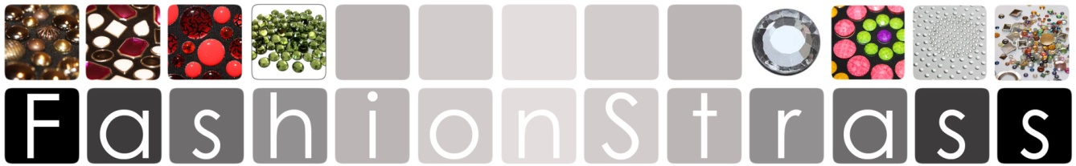
TECHNICAL INFORMATION

** IMPORTANT, BEFORE YOU BEGIN, READ THE USE AND MAINTENANCE INSTRUCTIONS FOR STICKY FLOCK MOLDS FOR REUSABLE STRASS CRYSTALS.

1-AFTER EACH USE, TAKE THEM CAREFULLY TO AVOID BREAKING THE SEPARATION BETWEEN HOLES SINCE IT IS VERY FINE, ADHER THEM TO THE SUPPORT ON WHICH YOU RECEIVED THEM AND STORE IN THE ENVELOPE IN WHICH THE ORDER IS COMING OR SIMILAR ADD DIRT TO THE ADHESIVE.

2- TO USE THE MOLDS USE A CLEAN AND SMOOTH SURFACE, SUCH AS A PLASTIC TRAY OR DIRECTLY ON A WOODEN TABLE OR
PLASTIC, AVOID CARDBOARD, PAPER, CARDBOARD OR SIMILAR SINCE THE ADHESIVE WILL GET STICKED AND YOU WILL NOT BE ABLE TO SEPARATE IT, AS A CONSEQUENCE YOU WILL NOT BE ABLE TO USE IT AGAIN.

3-IF YOU HAVE TO MOUNT ONE ON TOP OF THE OTHER IN THE CASE OF DRAWINGS IN TWO COLORS, IT IS ADVANTAGE TO ADHER A PIECE OF ADHESIVE PLASTIC TRANSFER PREVIOUSLY ON TOP SEVERAL TIMES TO REMOVE THE EXTRA HAIR, AS IT WILL NOT PUT IT IN THE OTHER .

4-IN THE CASE OF NOTING THAT THE ADHESIVE BEGINS TO LOSE ITS PROPERTY AND MOVES FROM THE SUPPORT, WITH A CLOTH WITH ALCOHOL, CAREFULLY CLEAN THE STICKED DIRT FROM THE SIDE OF THE ADHESIVE, THE TEMPLATE WILL BE READY TO USE AGAIN.

5-FOLLOWING THESE SIMPLE GUIDELINES, THE MOLDS MAY BE USED MANY MORE TIMES THAN IF YOU DON'T FOLLOW THEM, REDUCING THEIR COST MUCH MORE.

6-IF YOU HAVE ANY DOUBT OR PROBLEM, CONSULT US SO NOT TO PROCEED INCORRECTLY.

.
www.fashionstrass.com
Calle d’en Xammar nº1 ,08301 Mataro (Barcelona) TEL.625477949 email:info@fashionstrass.com

