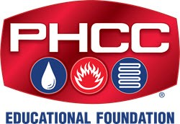
PHCC Educational Foundation Scholarships Background & Experience Questions to Answer

The online PHCC scholarship application requires detailed responses to these questions. You can use this form or just upload your own Word or PDF file with your answers. Provide 3 to 4 sentences at a minimum per question.

Save the file and upload it with your application form or e-mail it to scholarships@naphcc.org when you are done.

Your Name:
Your Cell #:
Your E-mail:

- What are your career goals, and how do you anticipate using your education in the plumbing-heating-cooling profession?

- Describe your work and personal development experience, with a focus on experience related to the plumbing-heating-cooling industry.

- Please explain why you are applying for educational financial aid, including any special circumstances or challenges you are facing in paying for your educational costs.

- Not including a PHCC scholarship, please detail how your upcoming tuition or training costs will be paid and who will be paying for these expenses (employer payments, personal savings, parents, job earnings, student loans, etc.)

- Provide a listing of your extracurricular and community service activities. Include information about leadership positions and awards earned.

